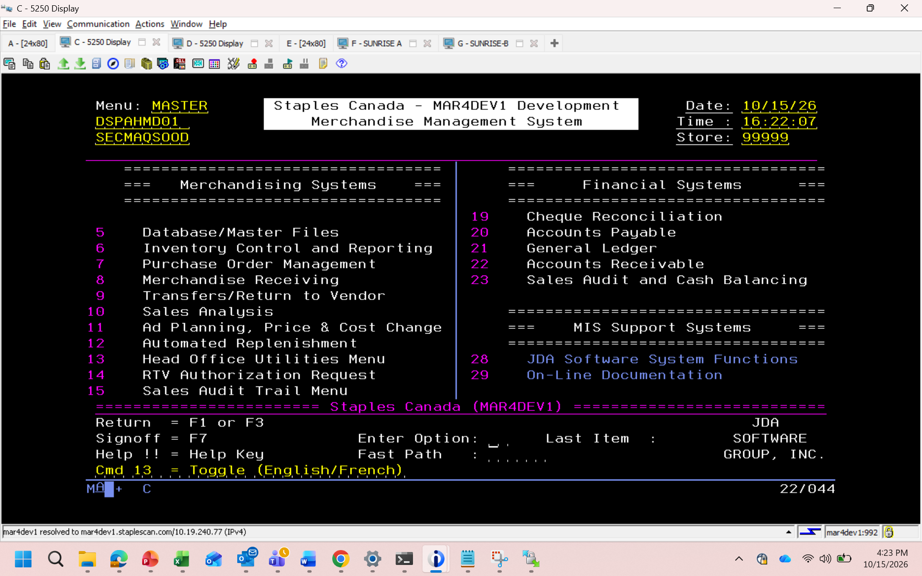
5
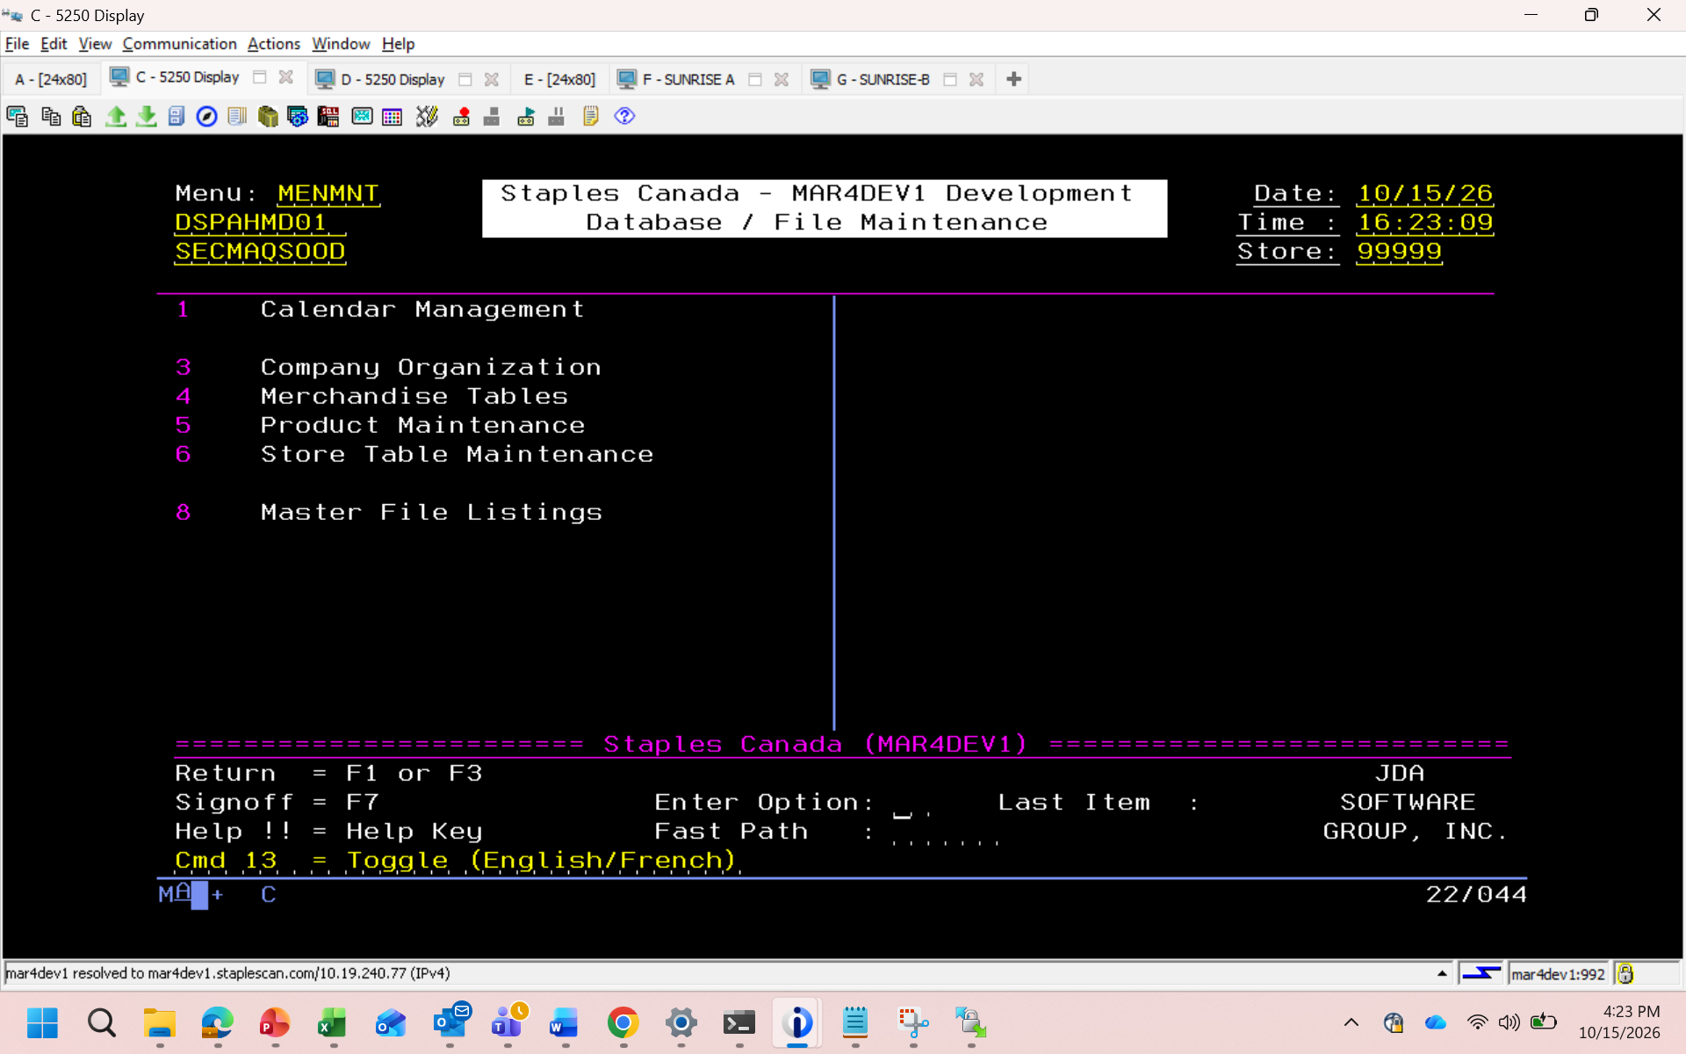
1
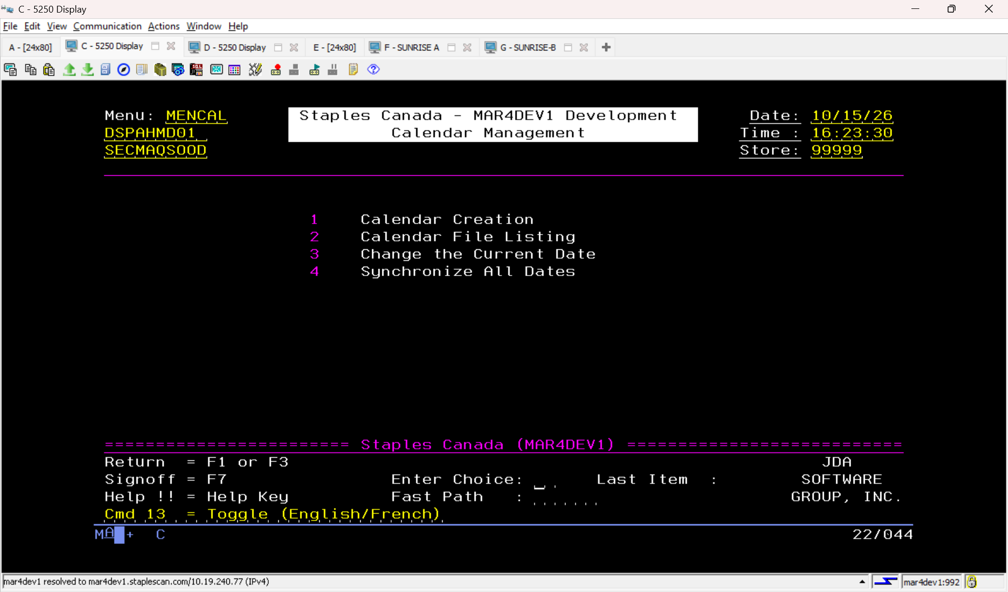
Option 3 company organization
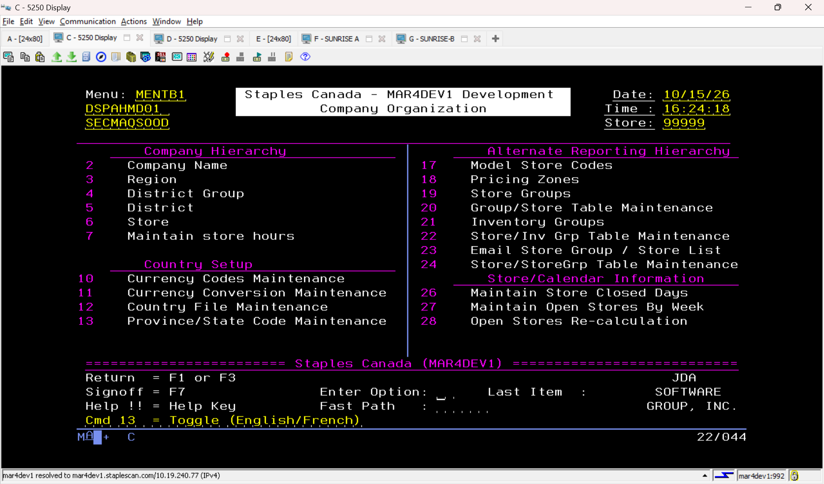
Mechandised tables
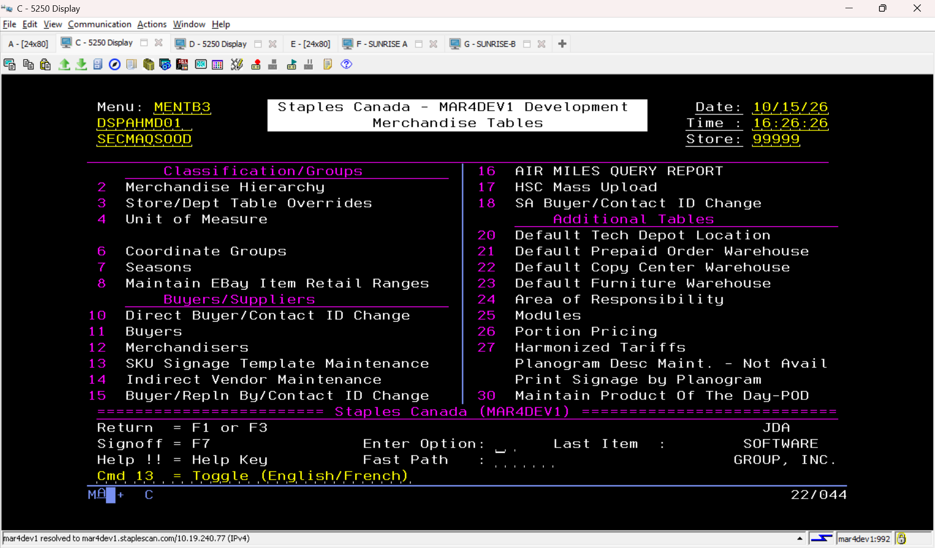
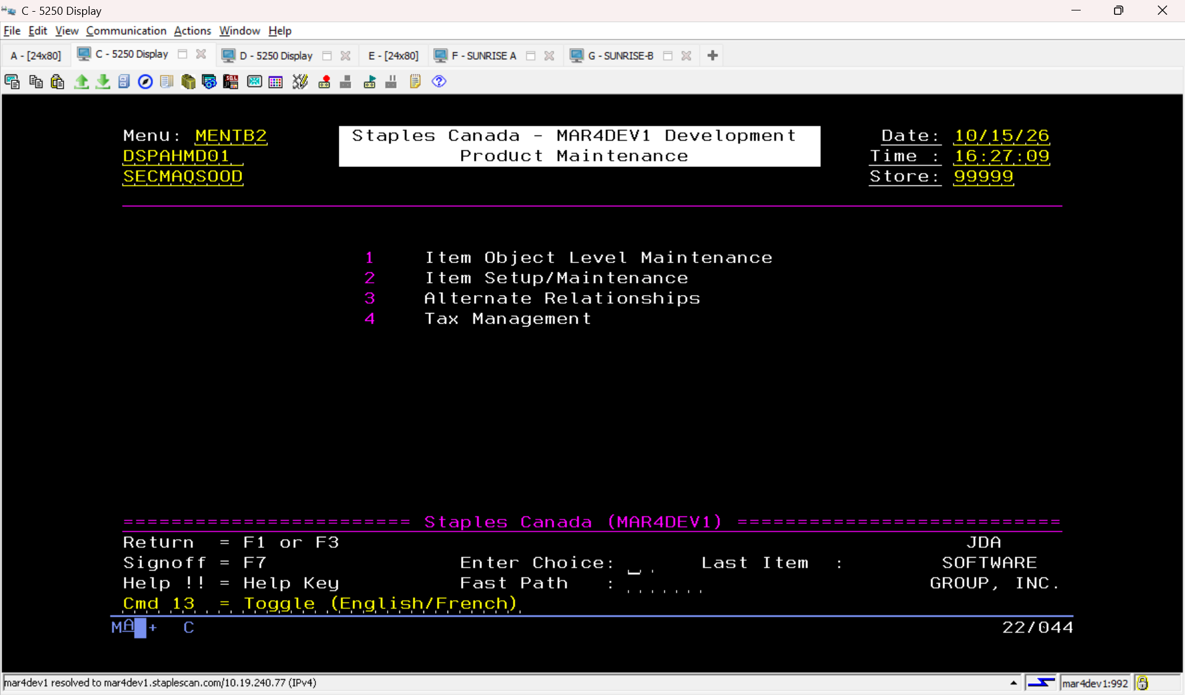
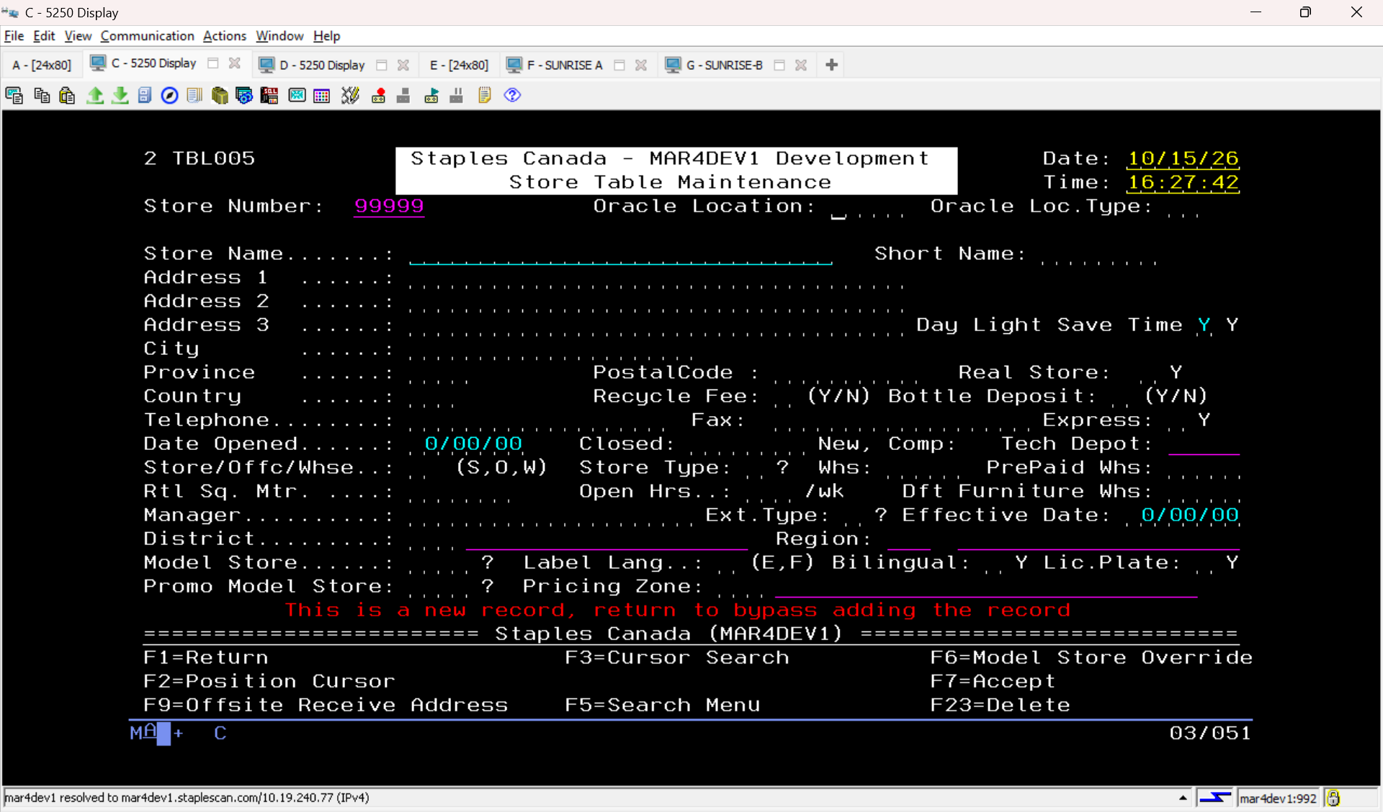
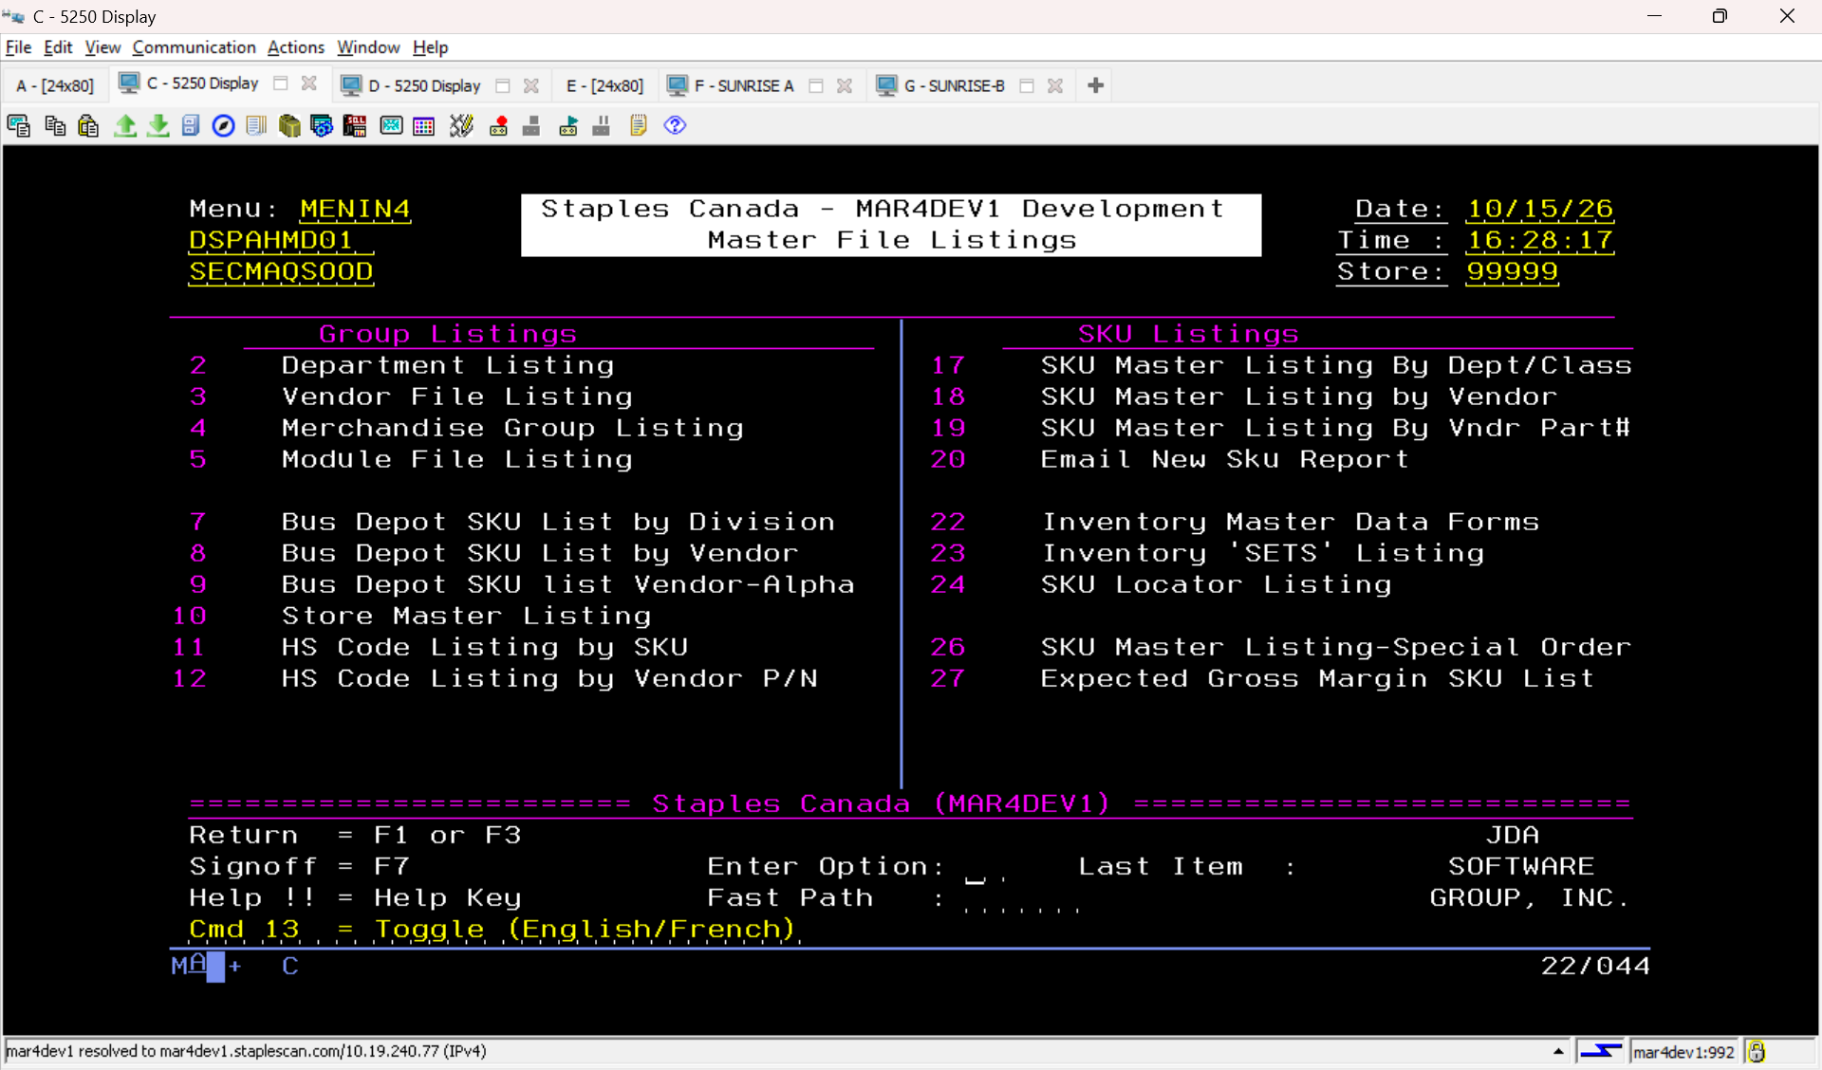
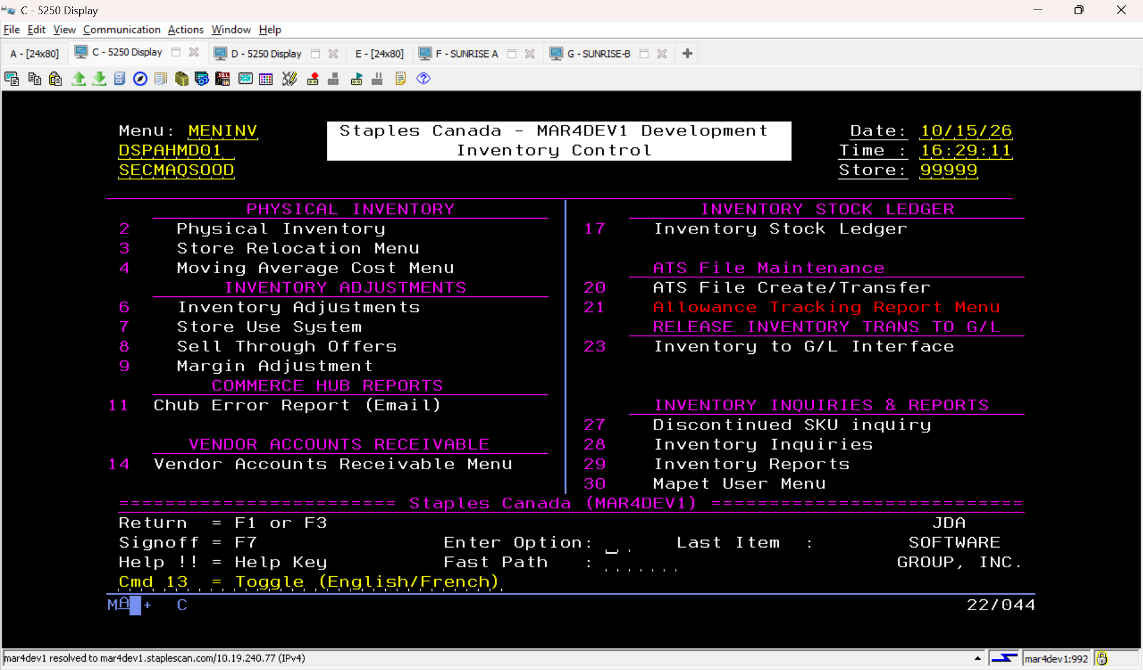
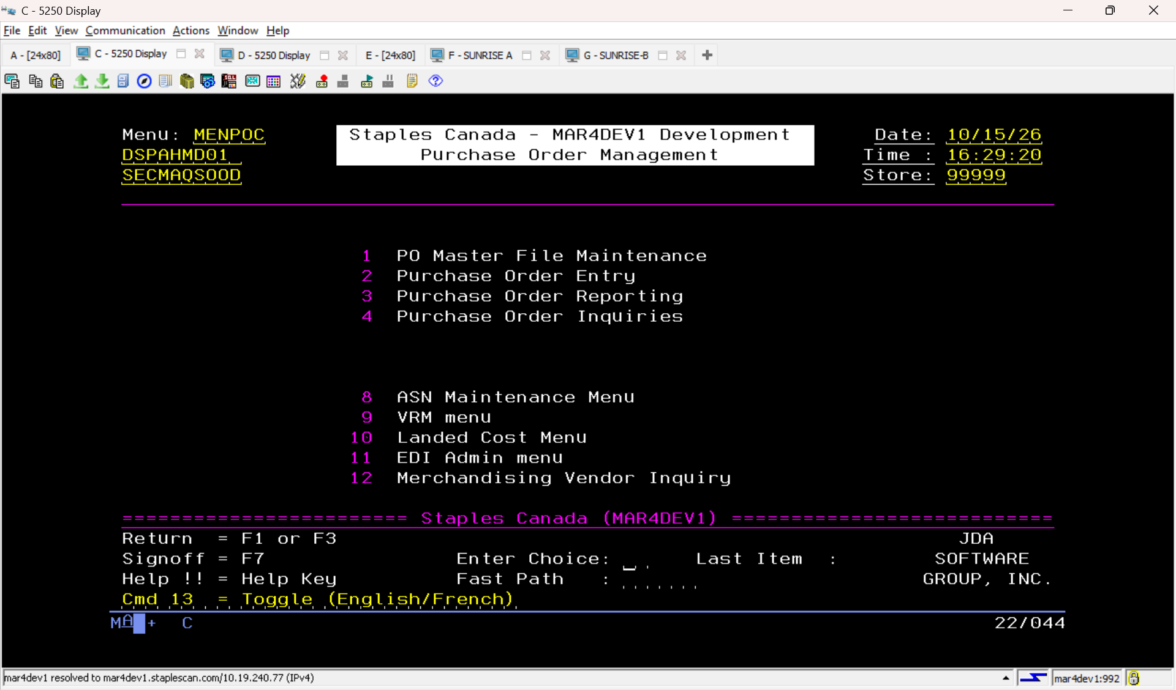
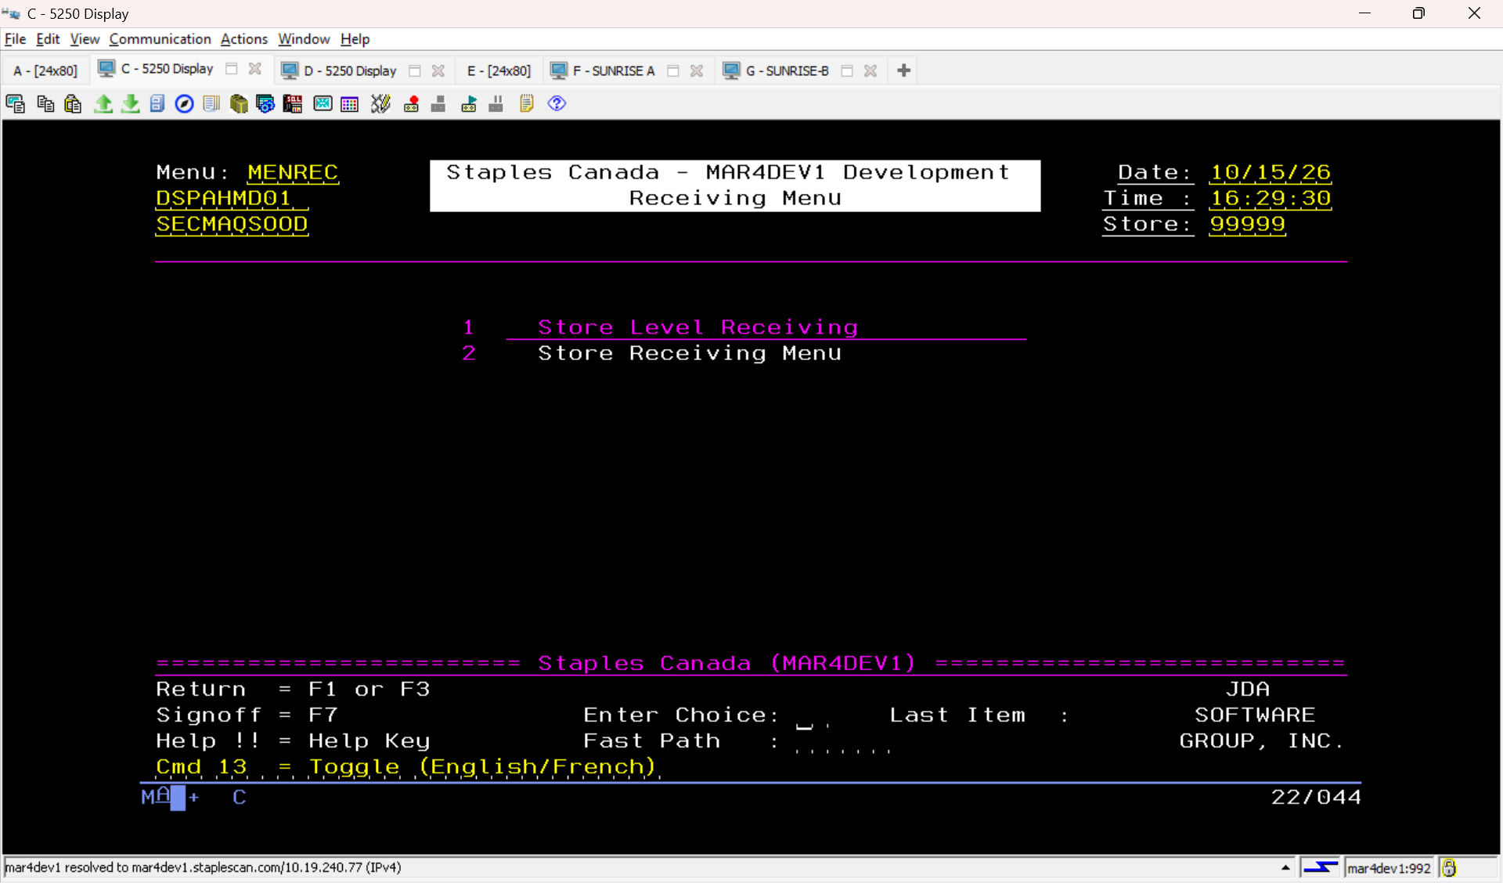
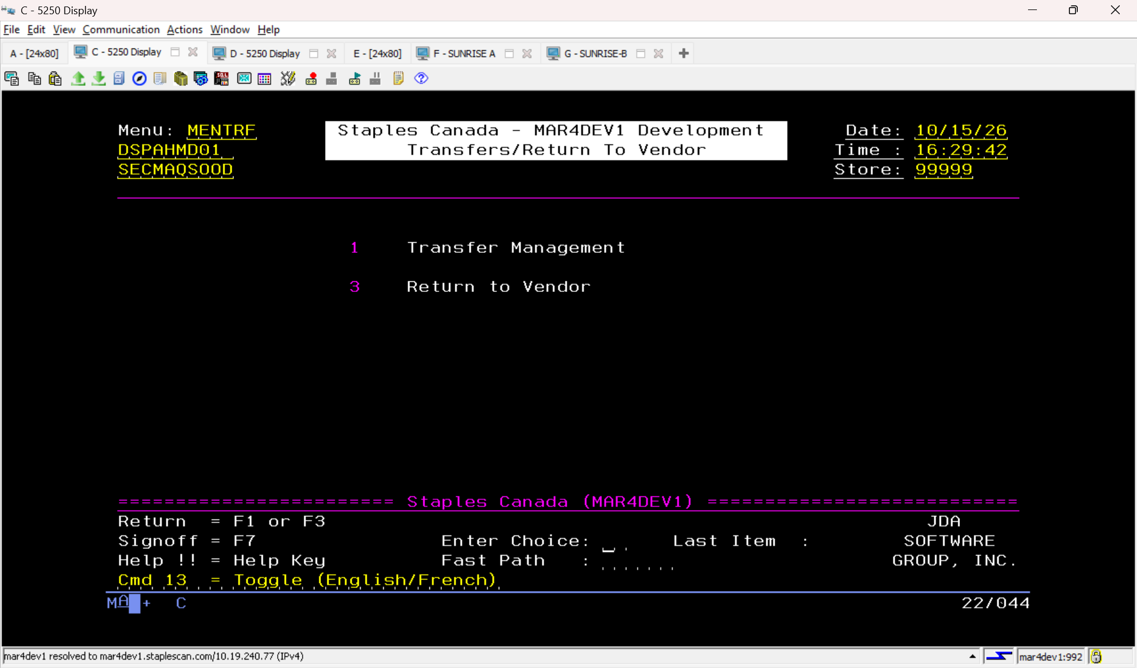
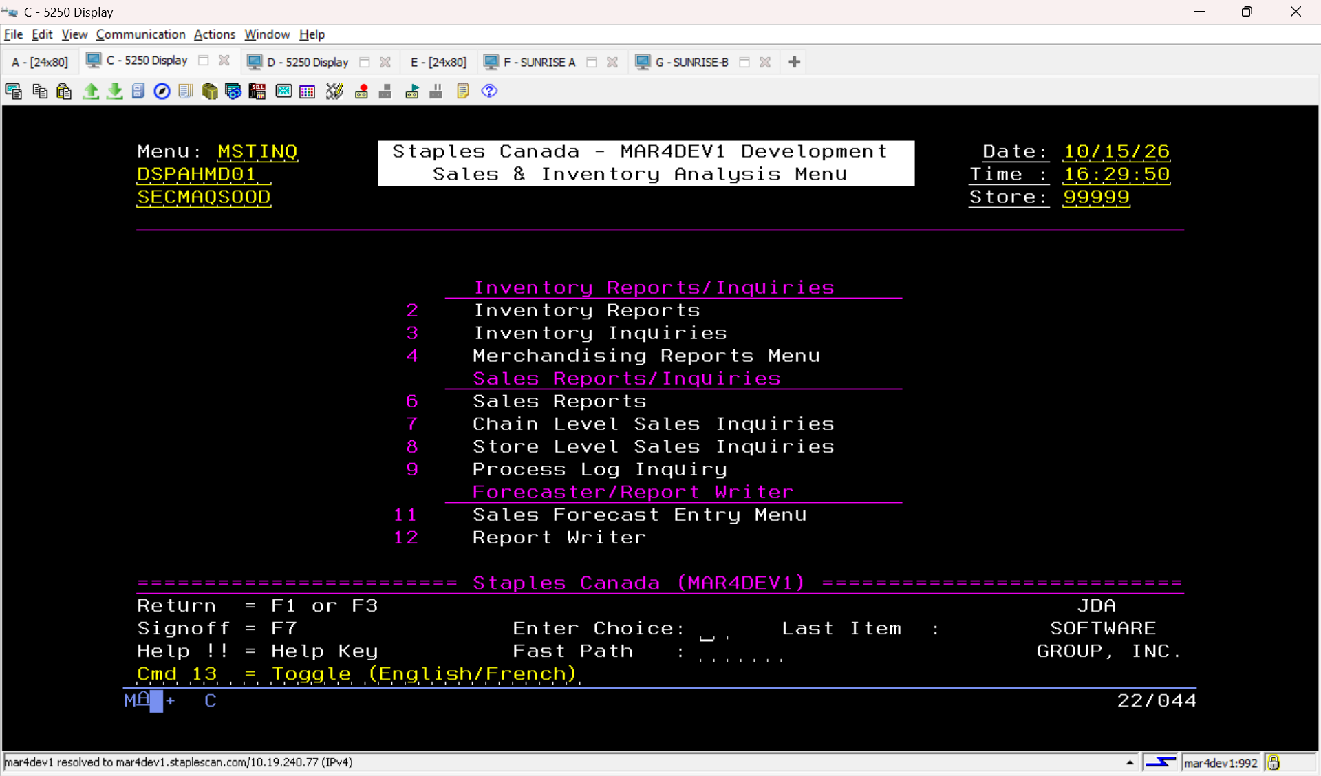
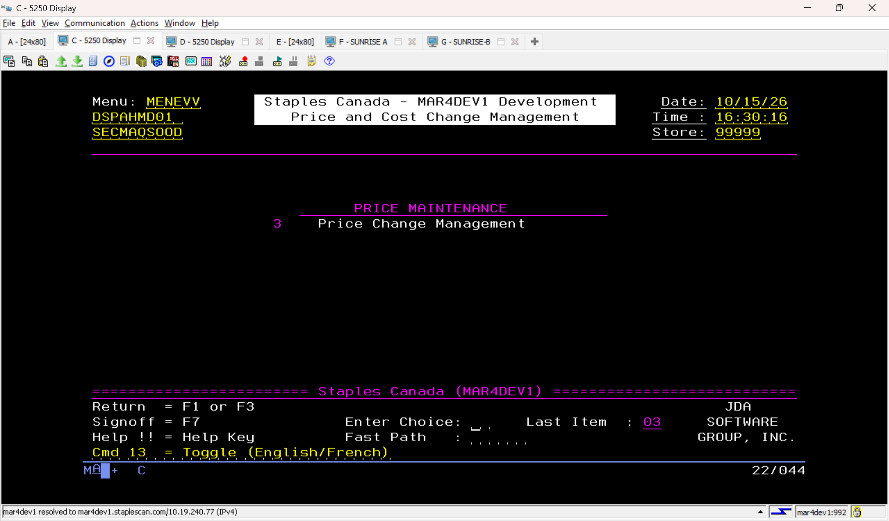
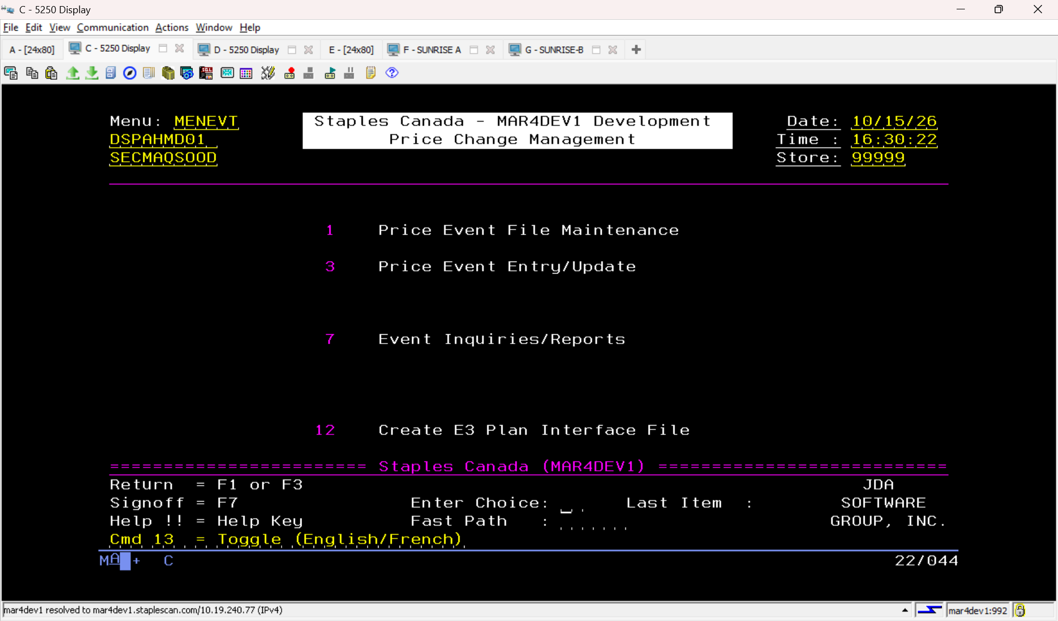
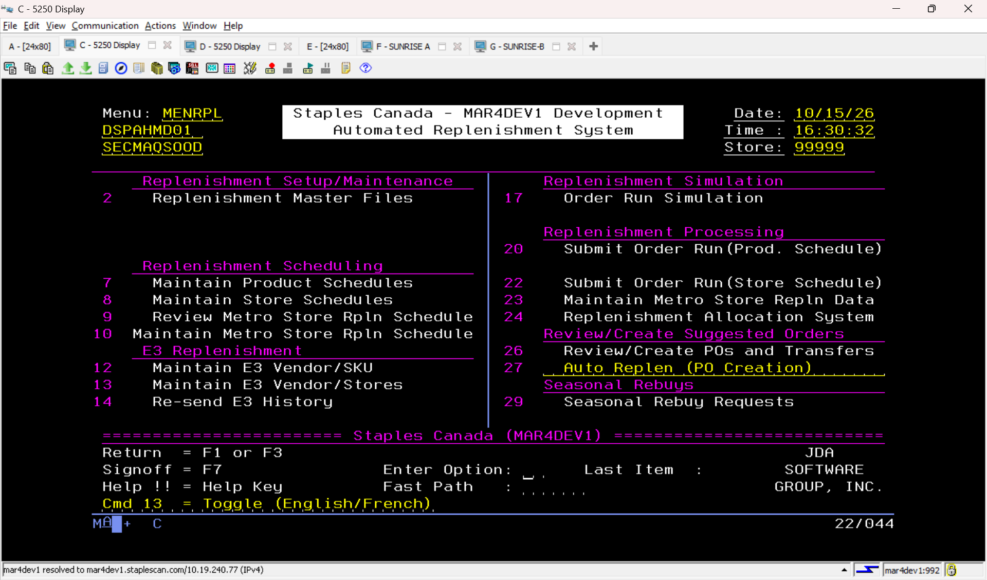
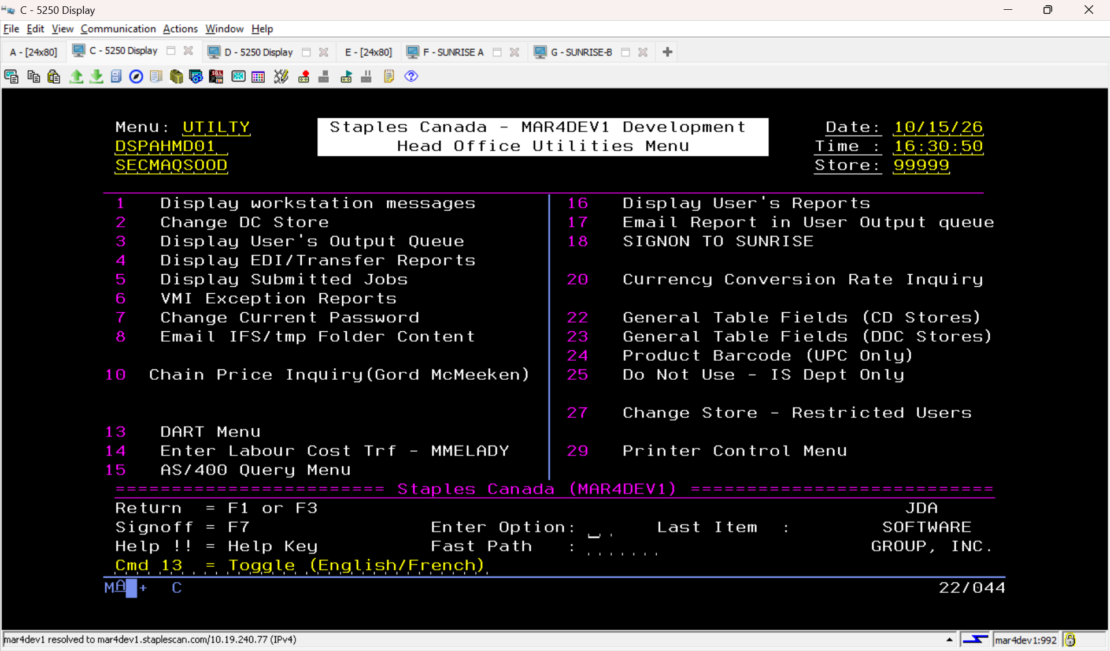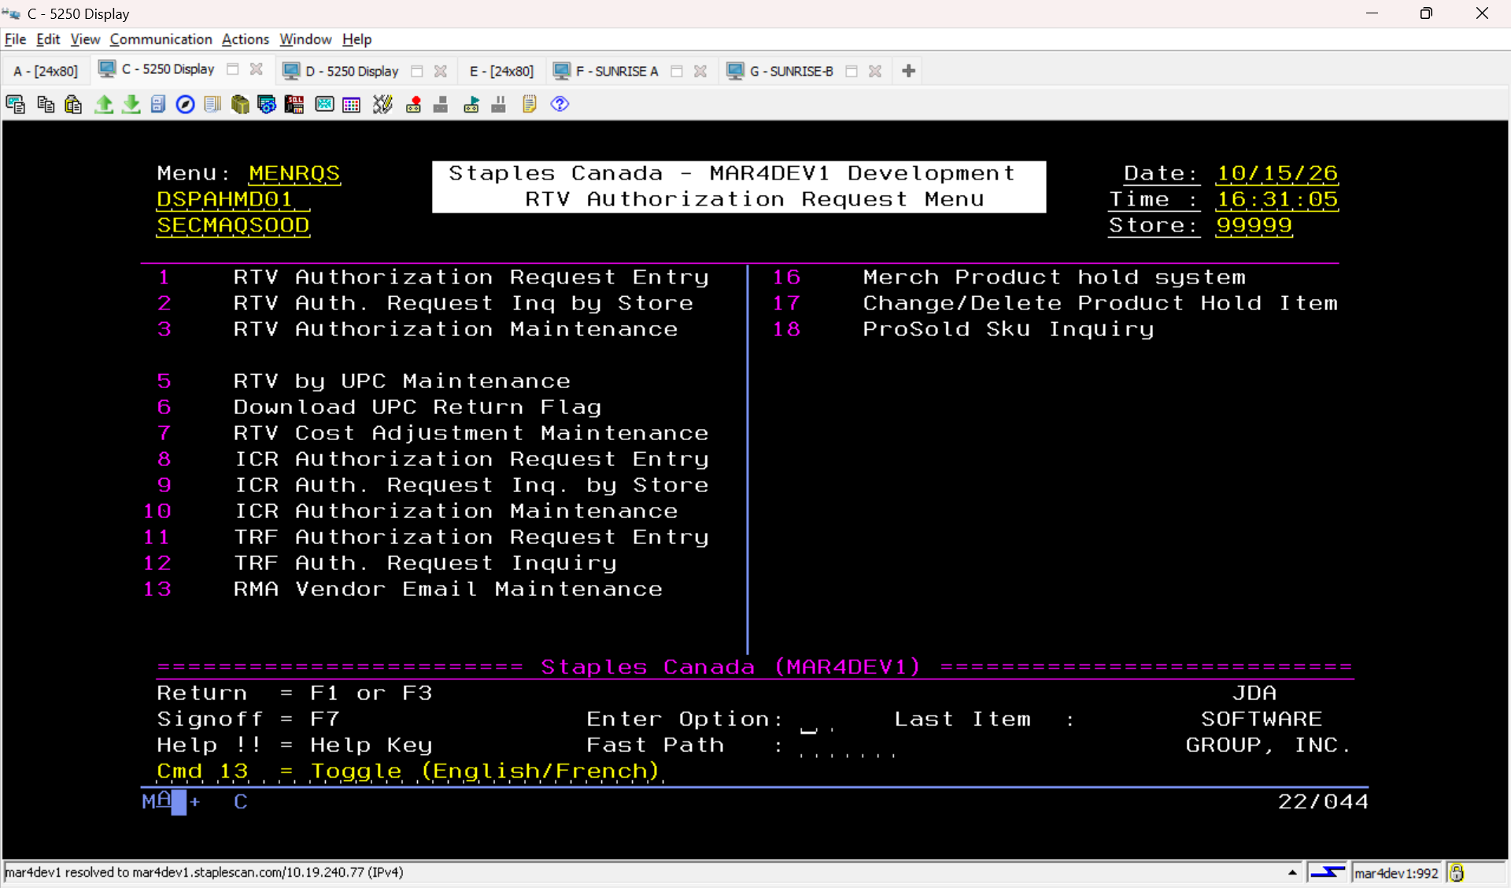
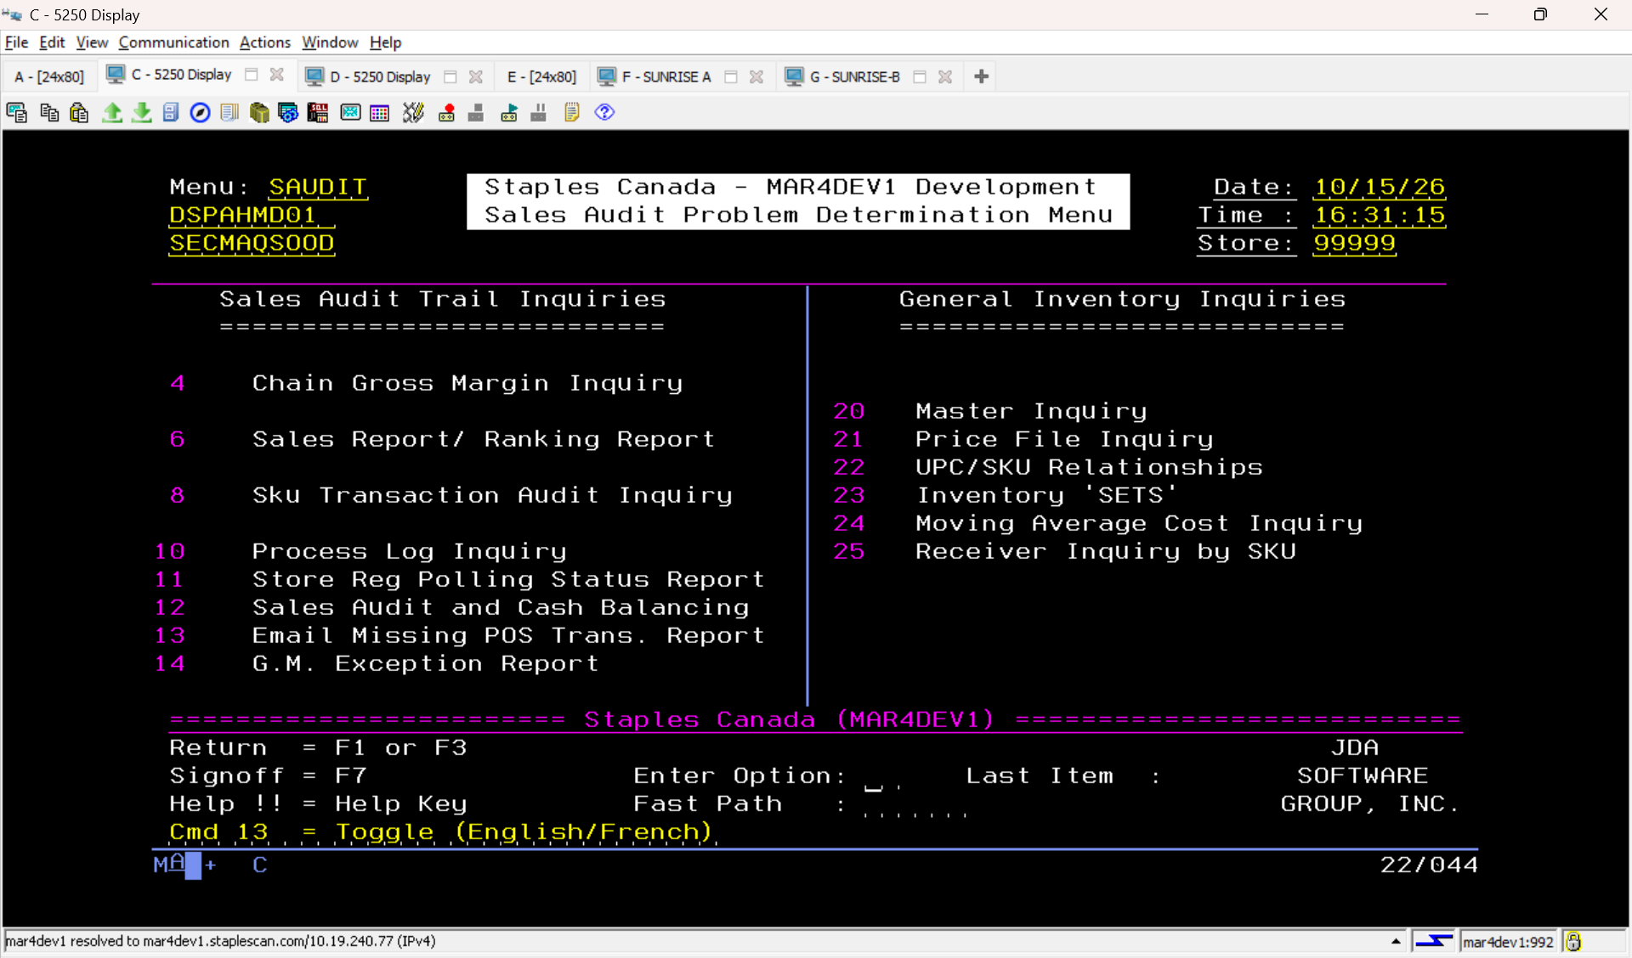
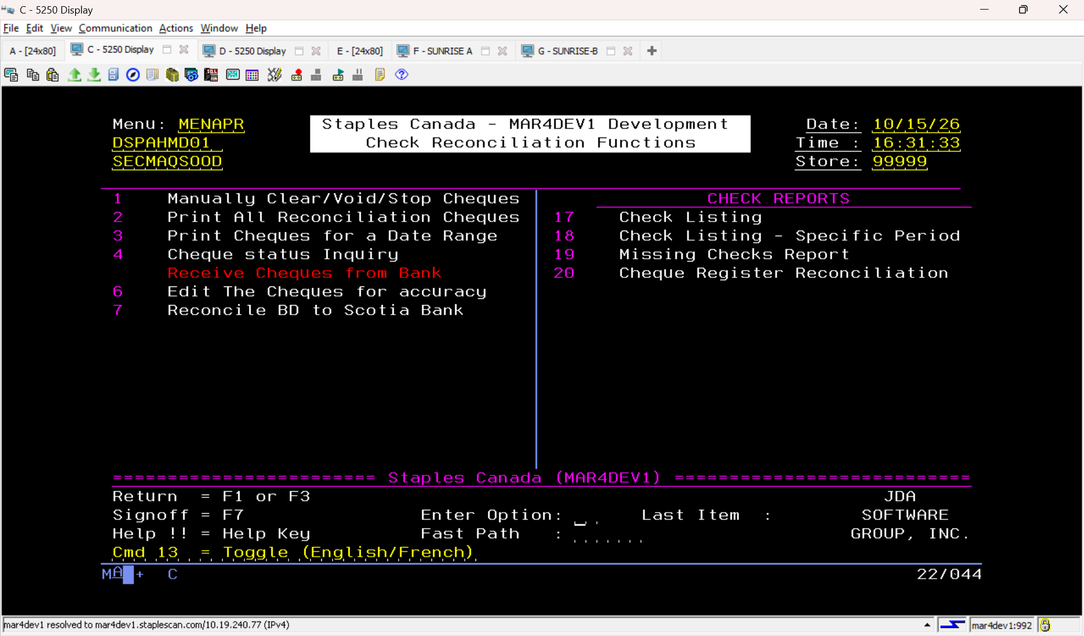
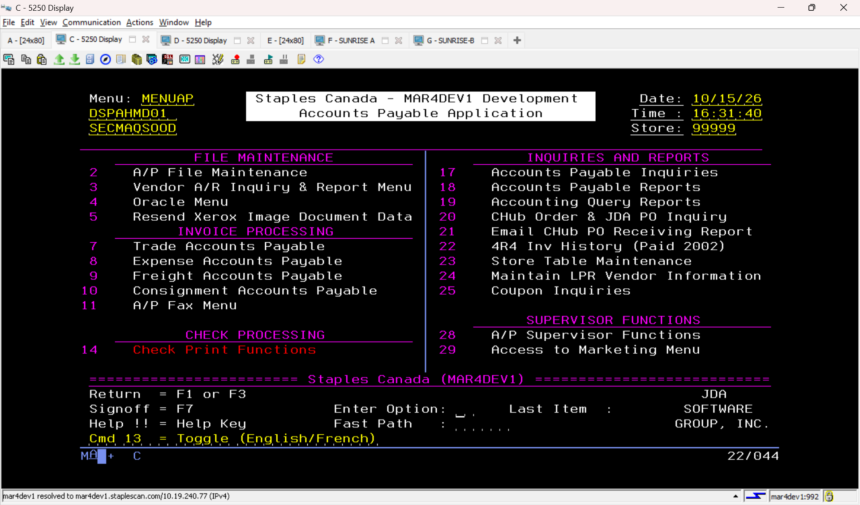
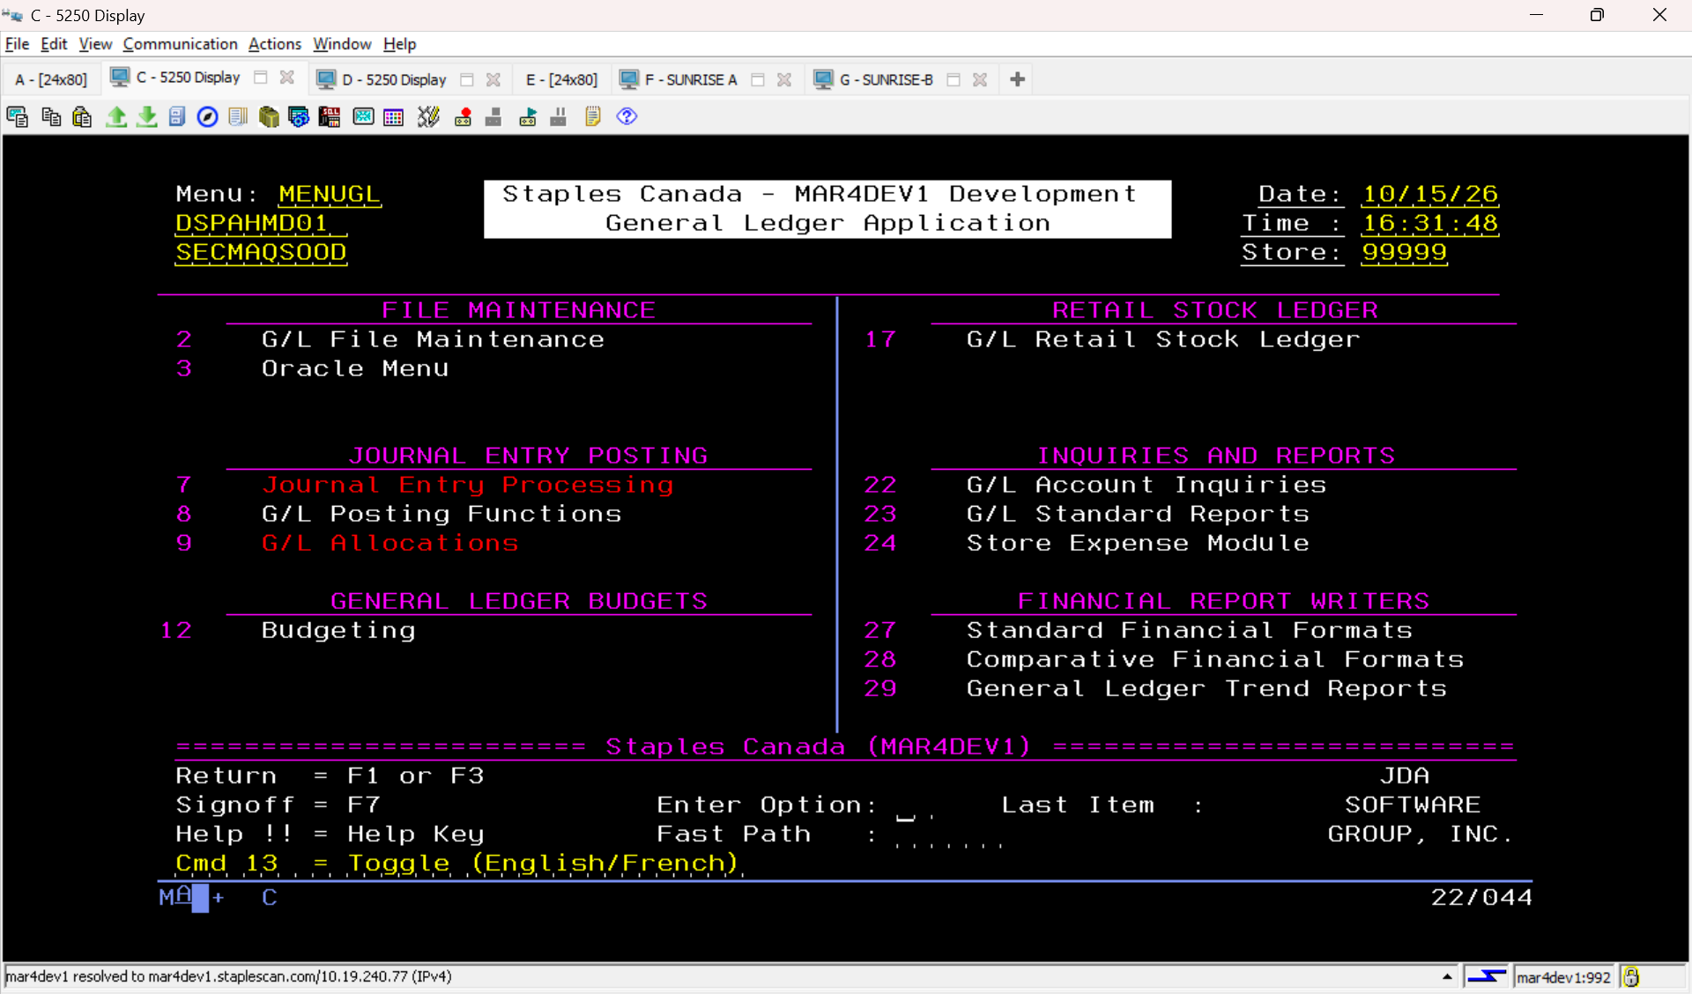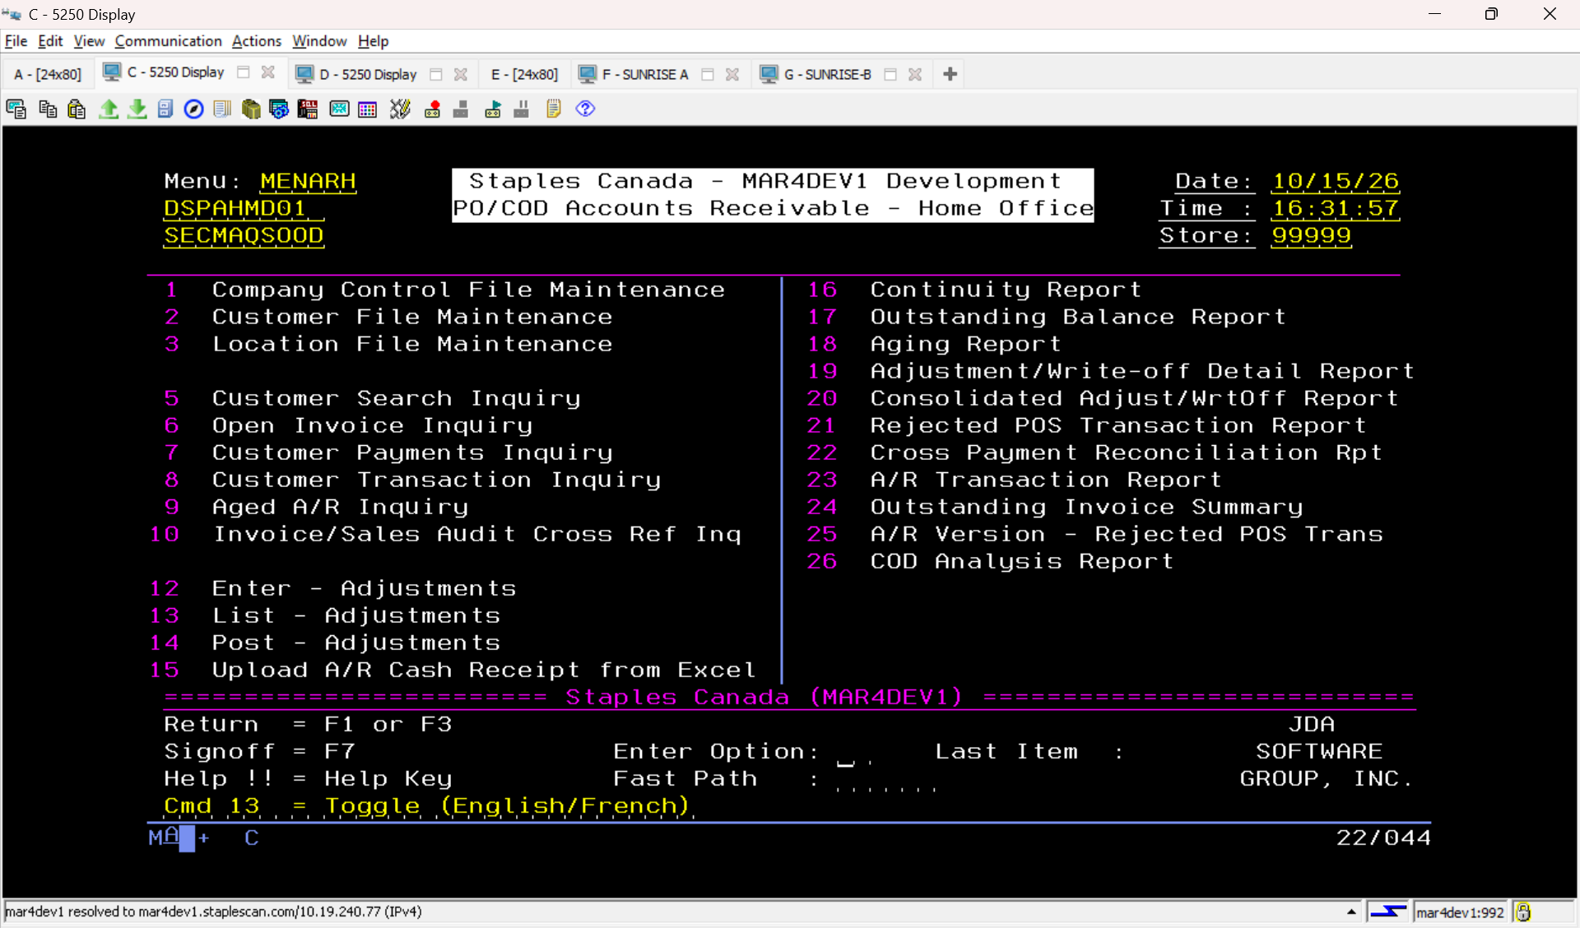
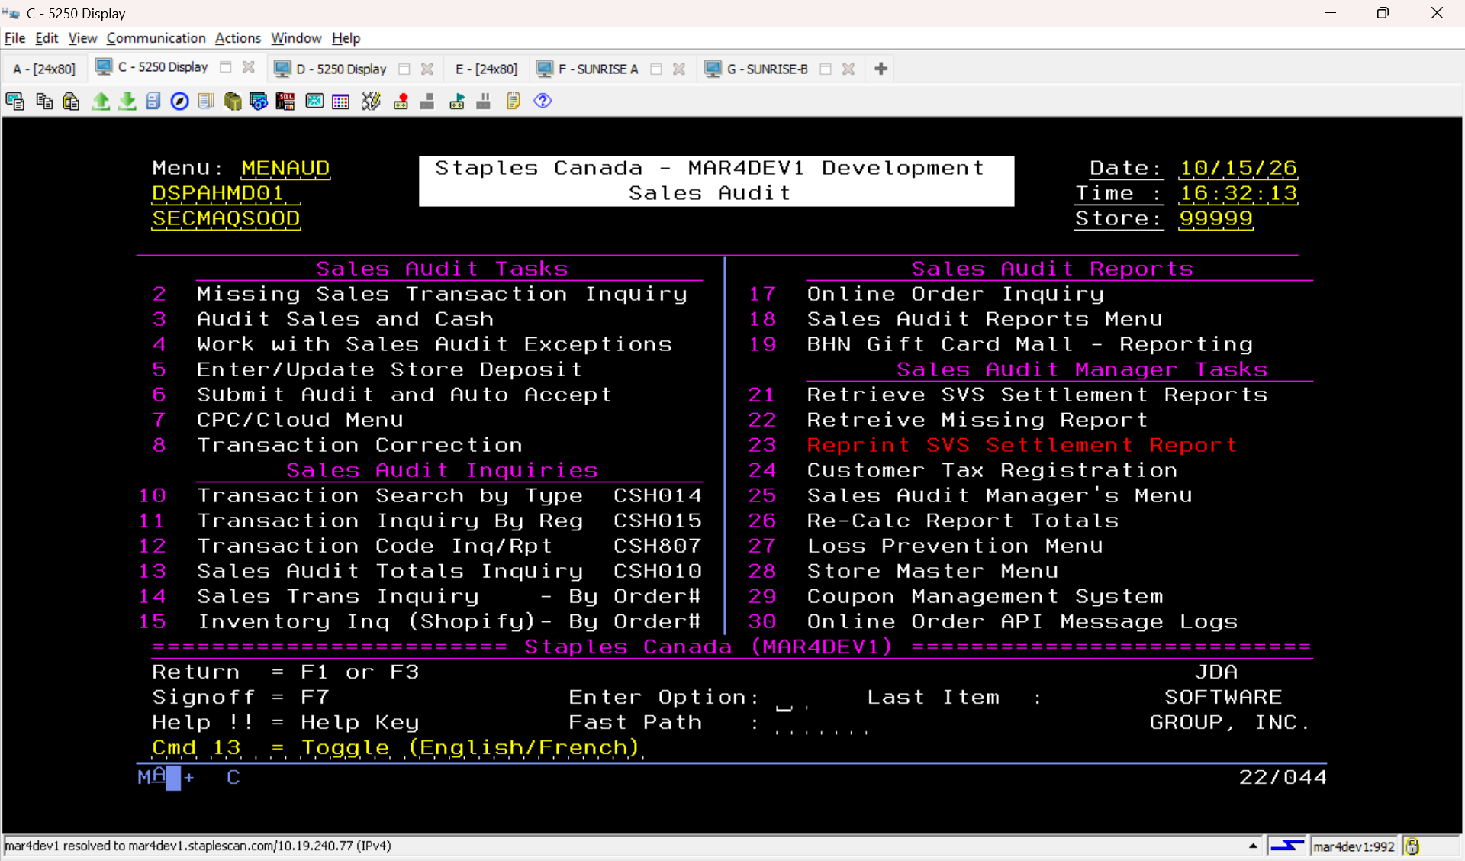
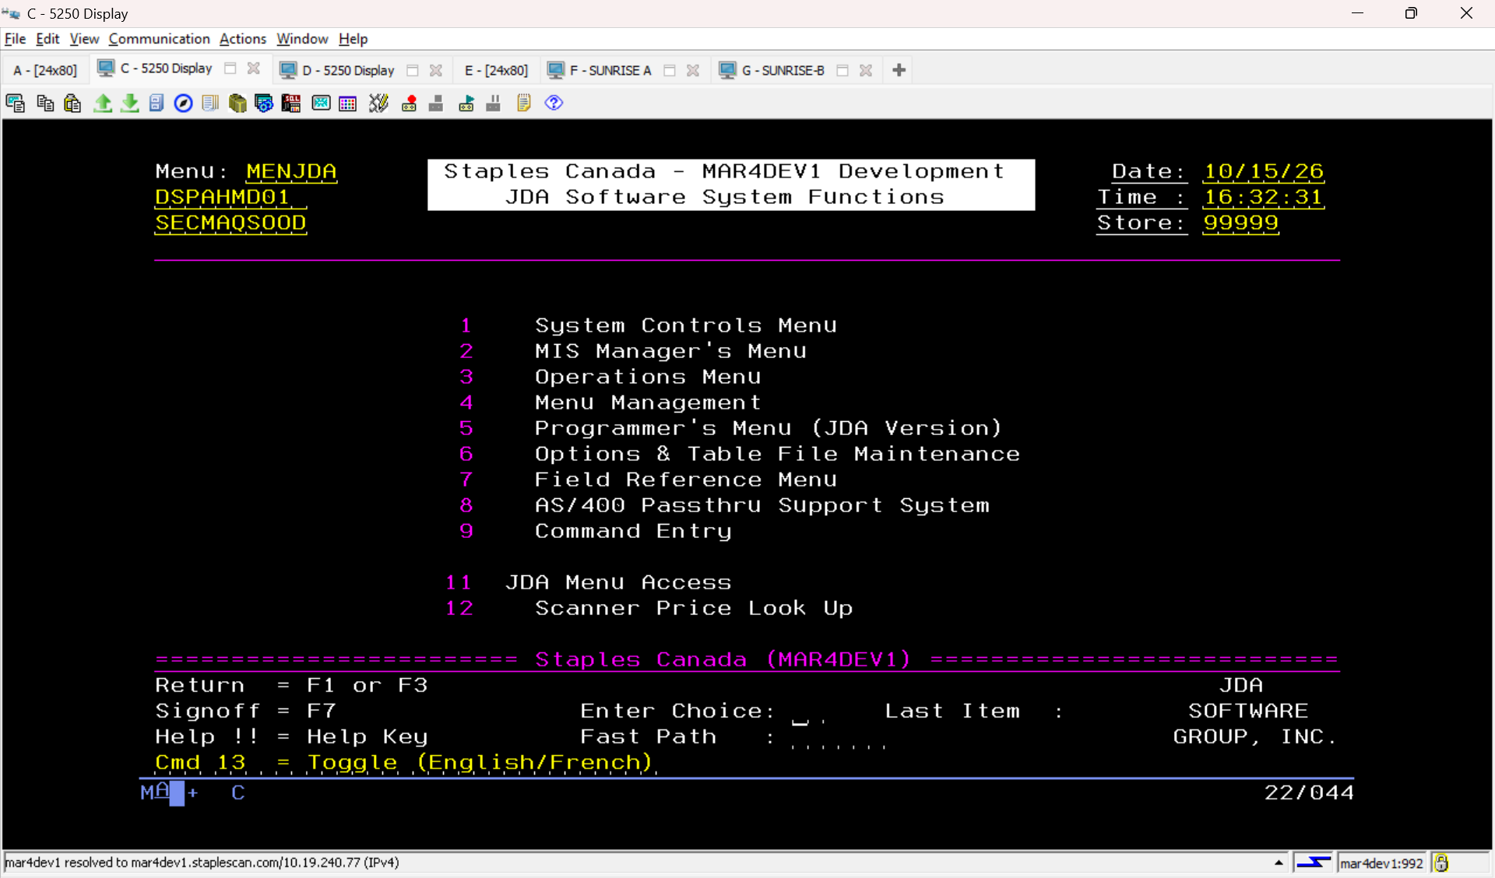
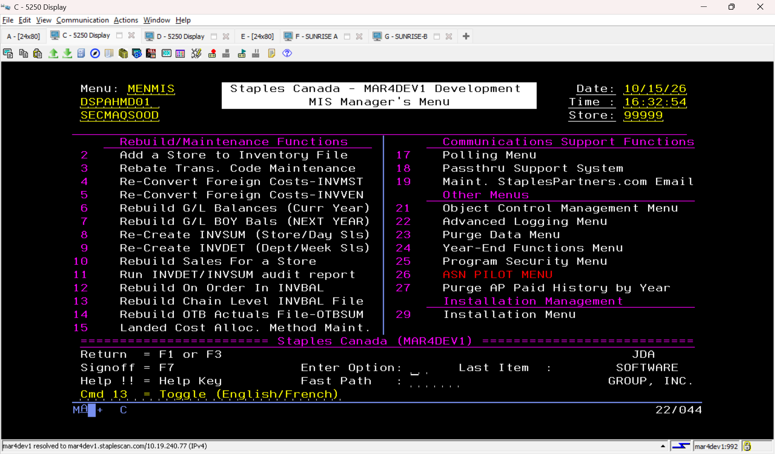
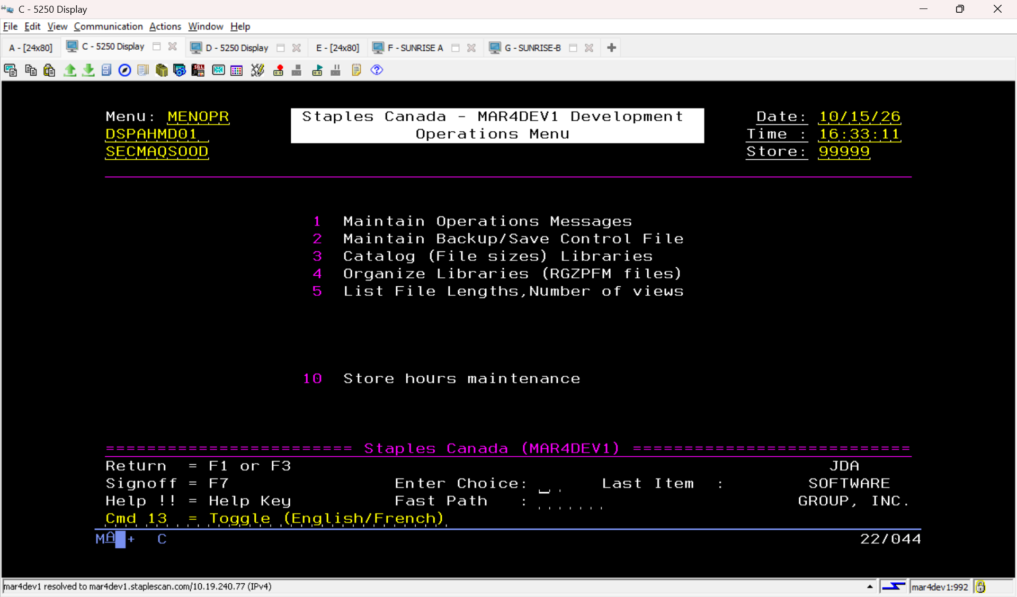
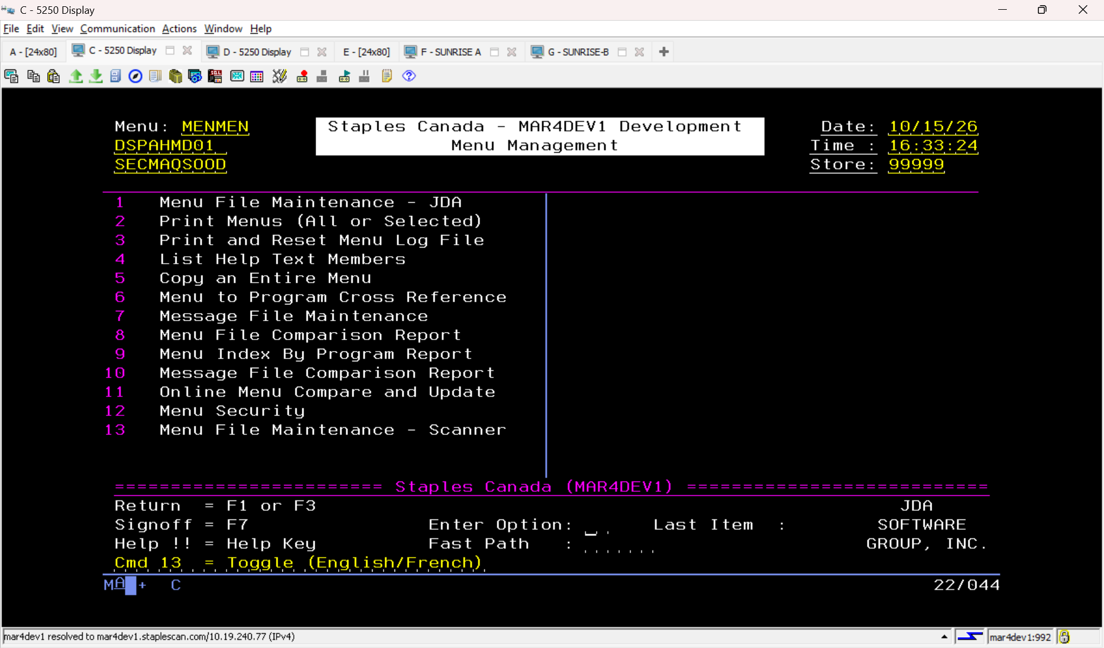
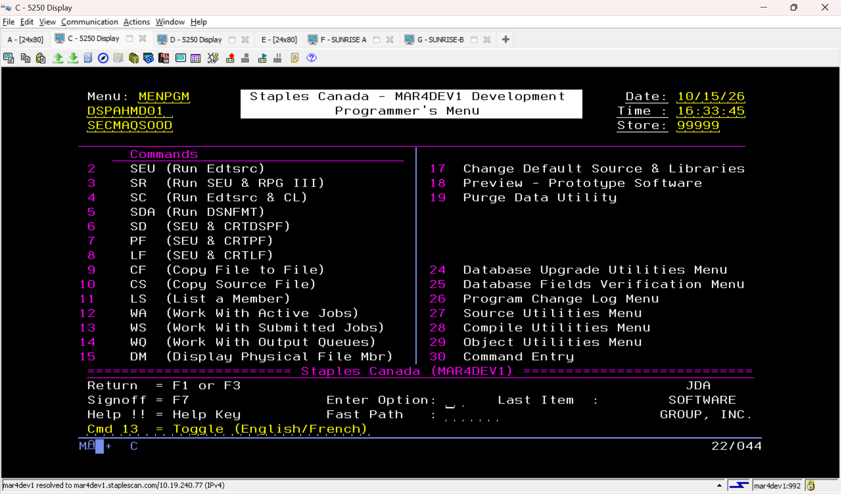
JDA MMS
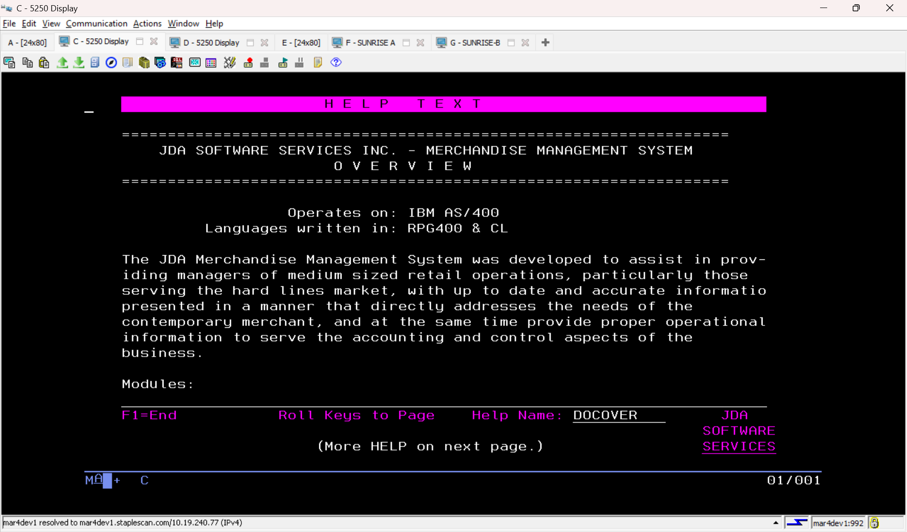
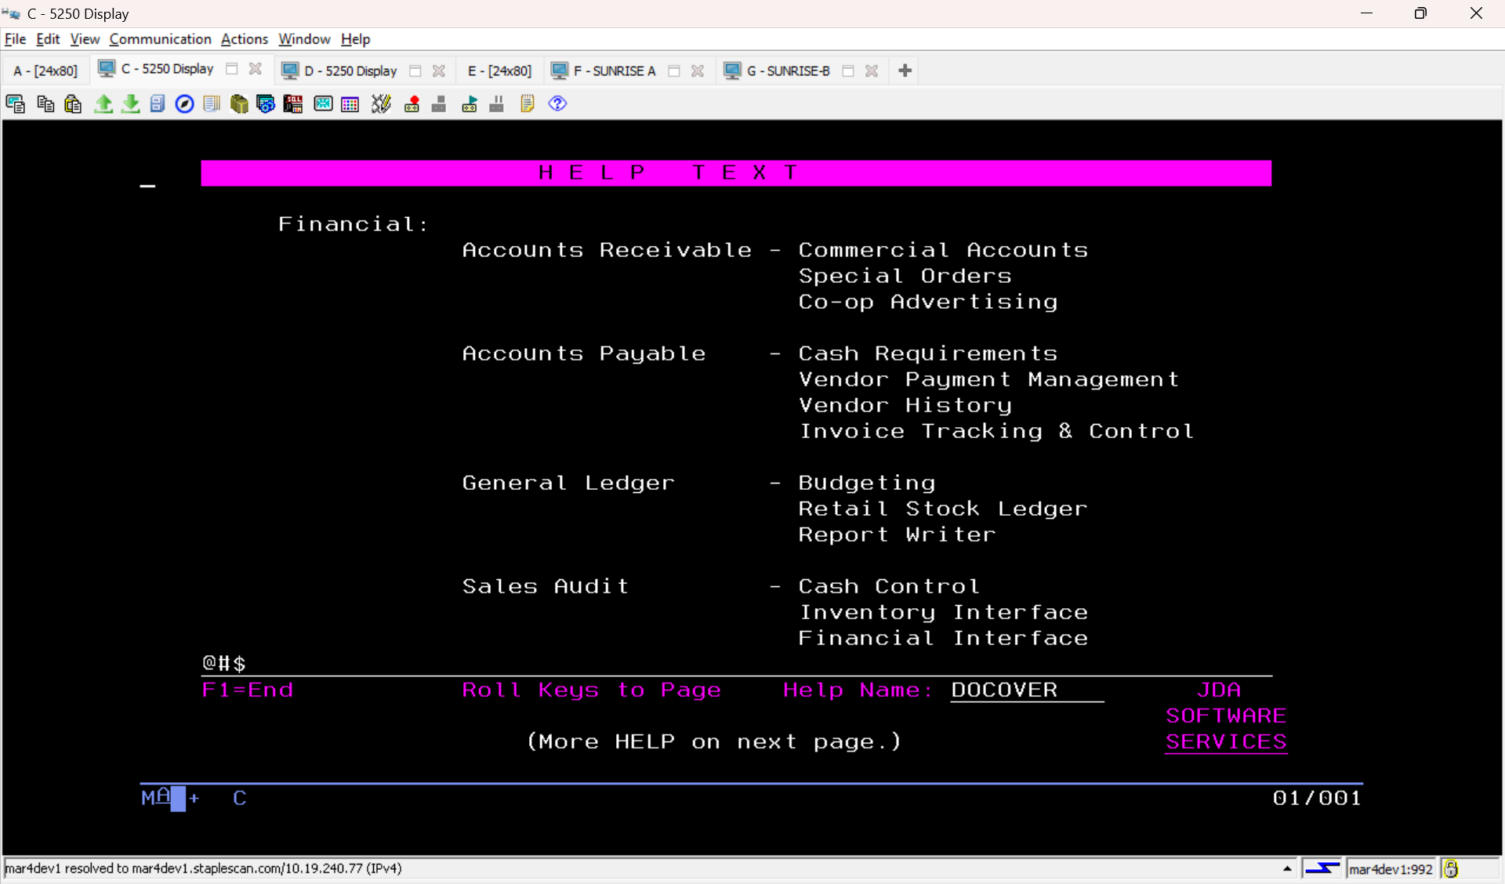
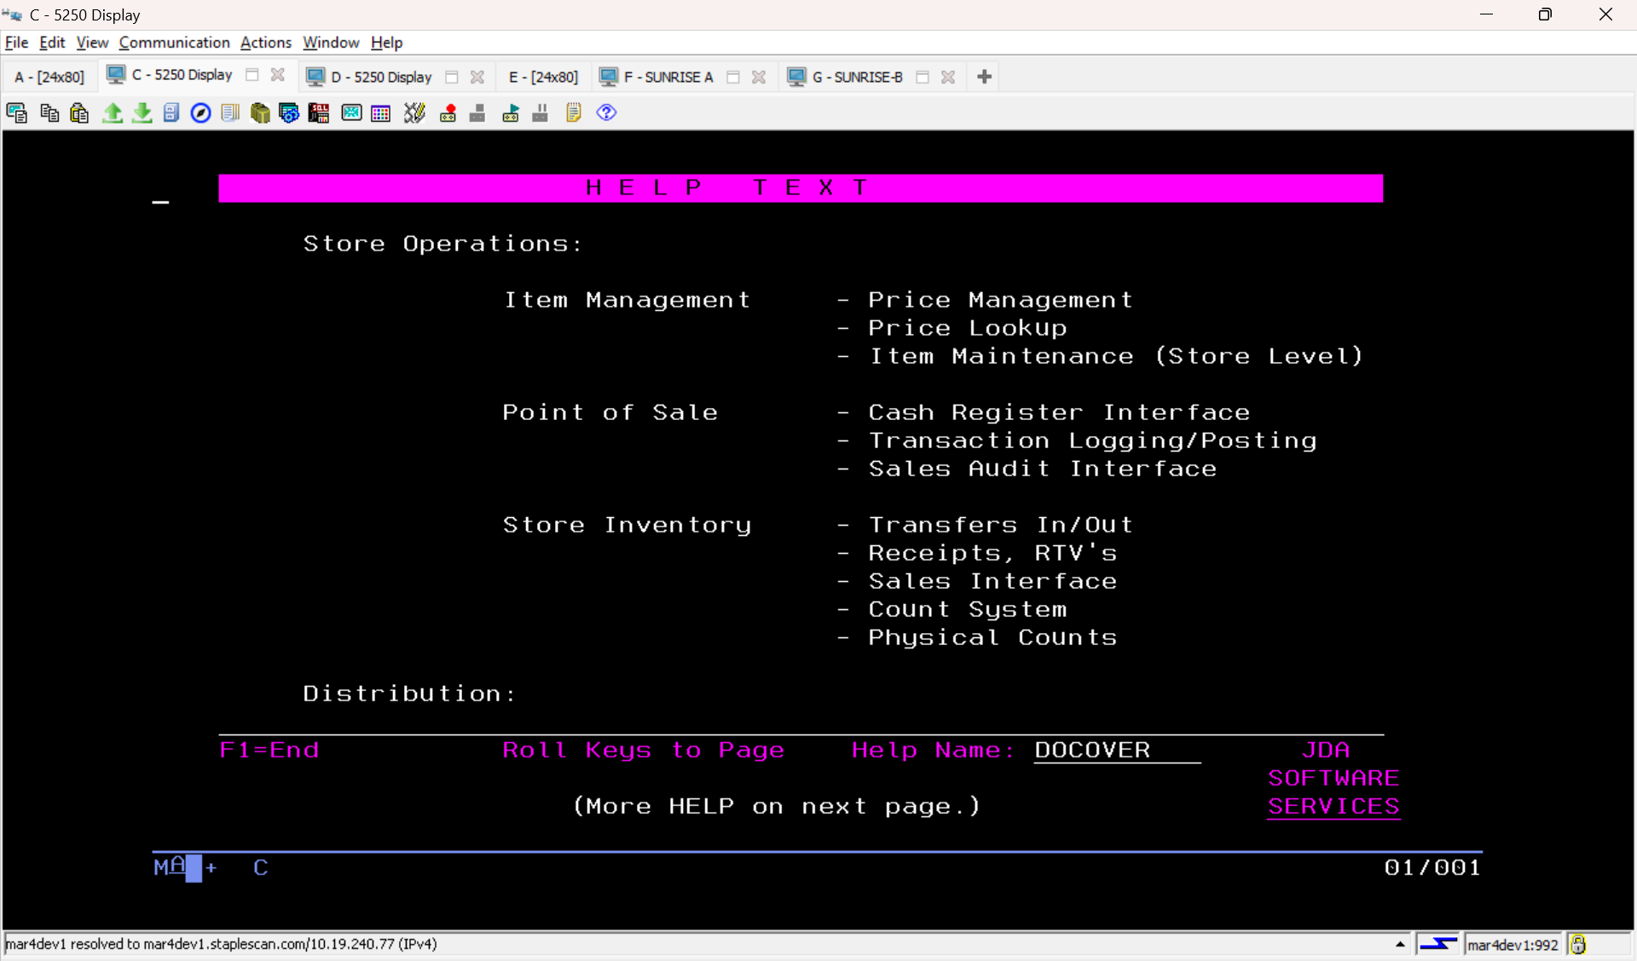
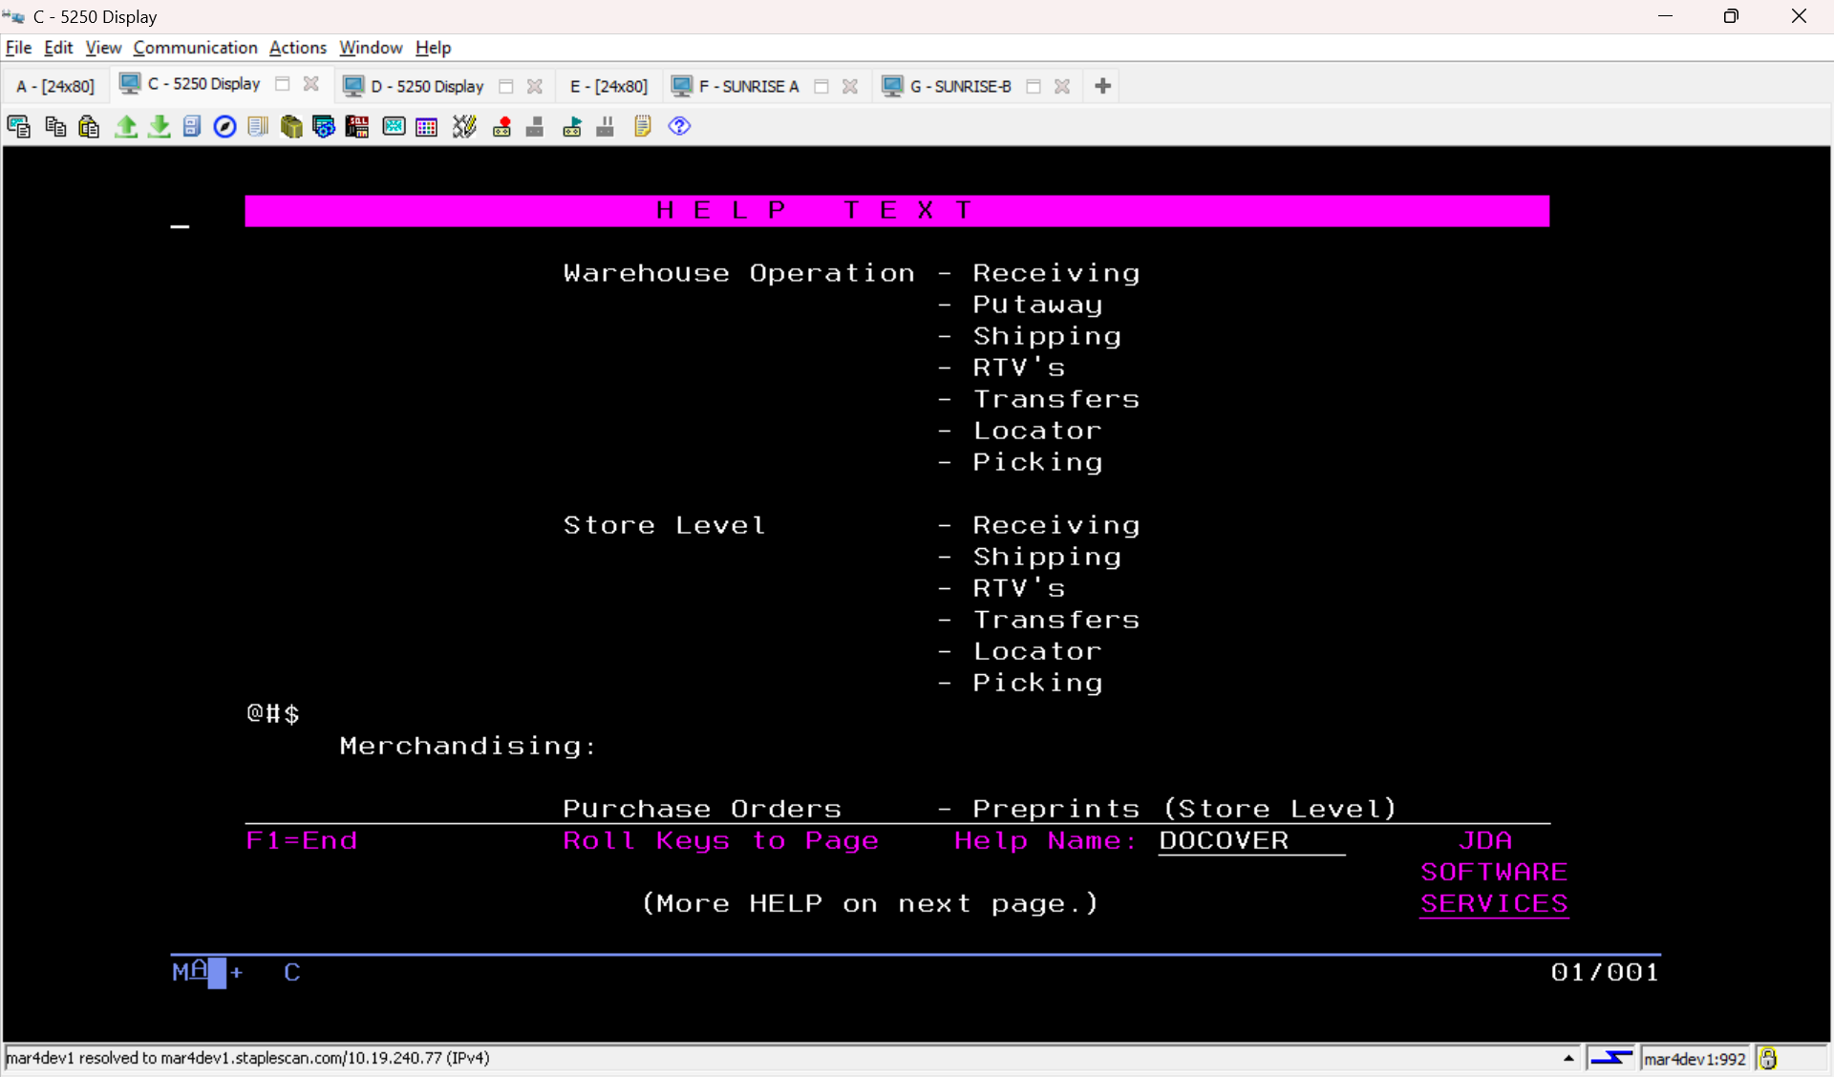
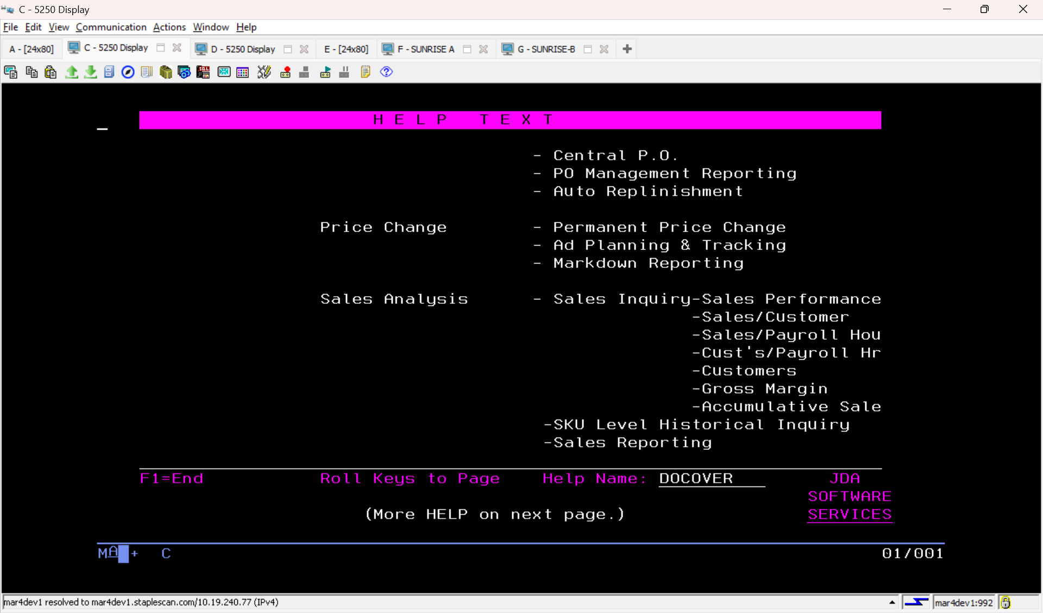
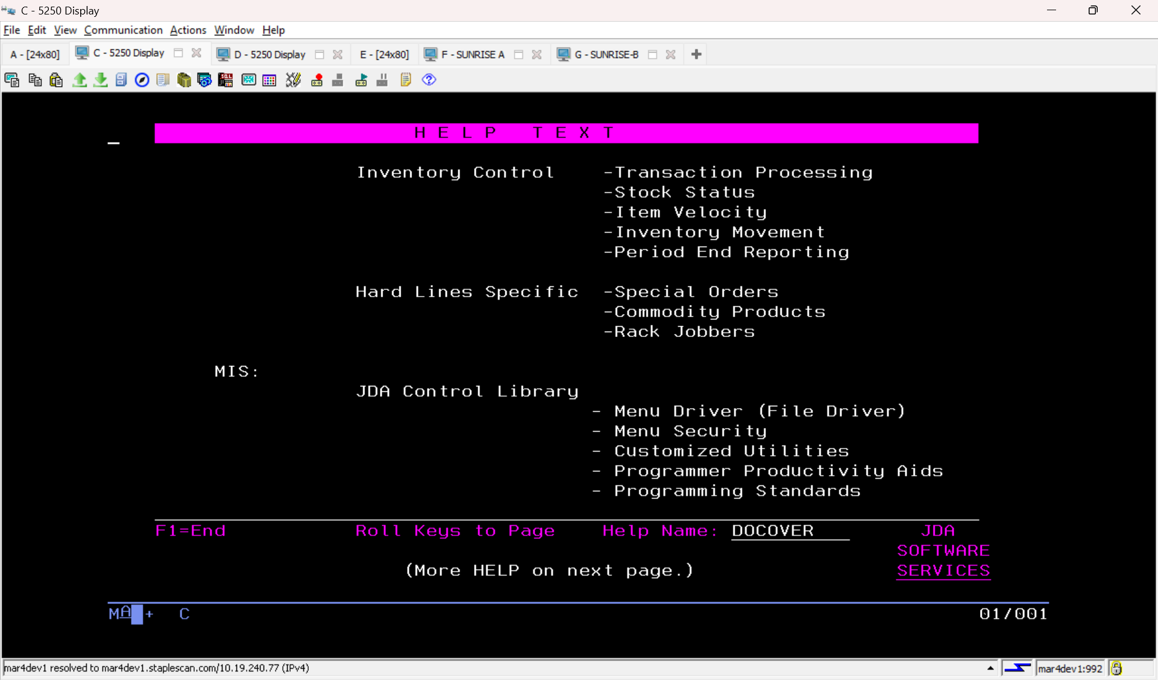
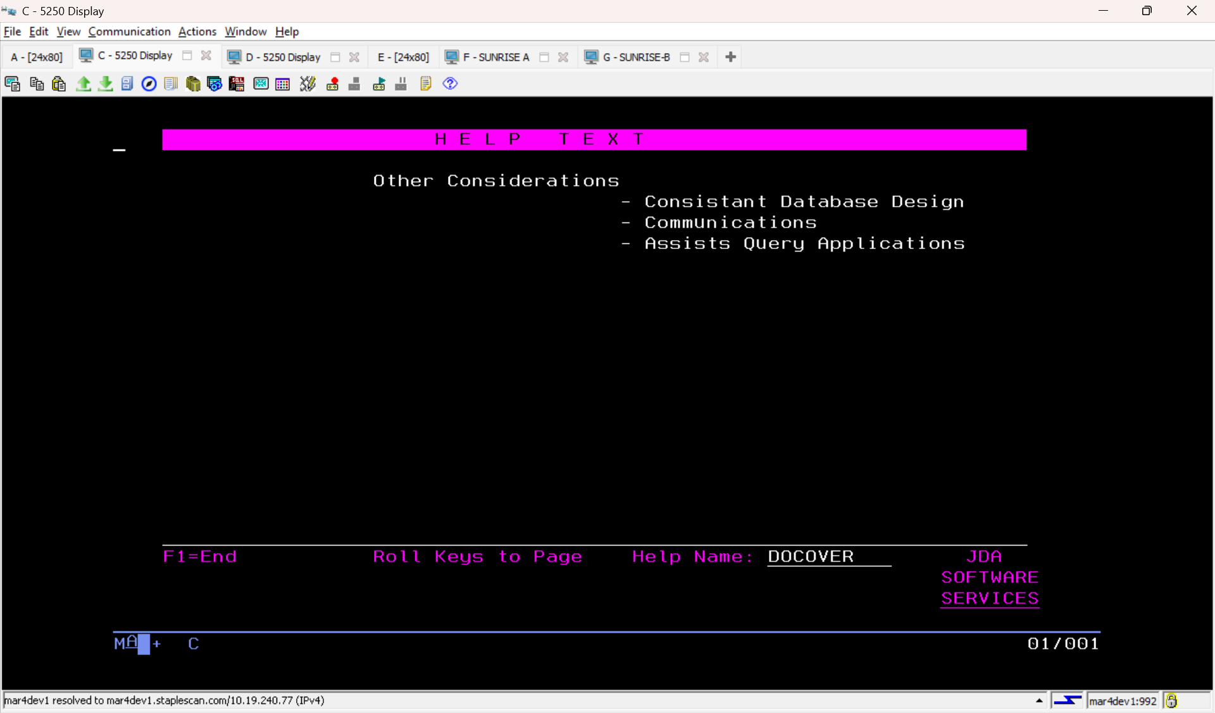

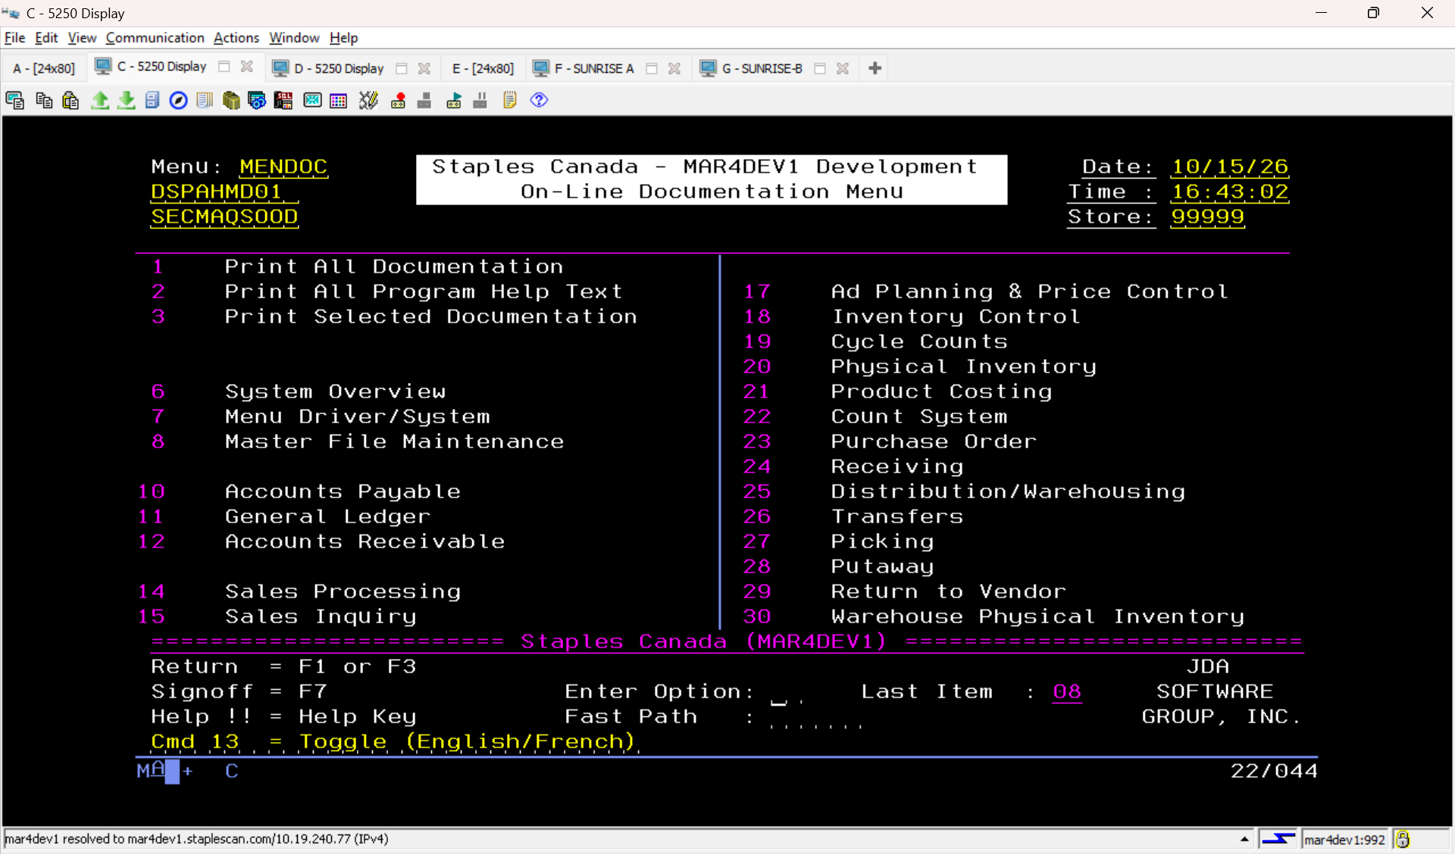
Libraries list
RBTSYSLIB | SYS | Robot SYSTEM LIBRARY
IBMMODS | SYS
QSYS | SYS | System Library
QSYS2 | SYS | System Library for CPI's
QHLPSYS | SYS
QUSRSYS | SYS | System Library for Users
BDSYS | SYS | SYSTEM CONFIGURATION OBJECTS for MAR4DE
QTEMP | USR
BDCHGCTL | USR
JDACHGCTL | USR | JDA Change Control System
TOOLS4R4 | USR | JDA Development Tools
MMDEVSYS | USR | Business Depot Development Library
MMTSTSYS | USR | Test System System files
MMBUSSYS | USR | Business Depot System Programs
MM4R4SYS | USR | JDA MMS System Programs 4R4
MMDEVCTL | USR | Business Depot Development Control Libr
MMDEVSRC | USR | Business Depot Development Source Libra
MMTSTSRC | USR | Test System Source files
MMBUSSRC | USR | Business Depot Source Files
MM4R4SRC | USR | JDA MMS Source Files 4R4
MMDEVLIB | USR | Business Depot Development Database
MMDEVPGM | USR | Business Depot Development Program Libr
MMTSTPGM | USR | Test System Program Object Library
MMBUSPGM | USR | Business Depot Program Object Library
MM4R4PGM | USR | JDA MMS Program Objects 4R4
MM4R4HLP | USR | JDA MMS Help Files 4R4
QGPL | USR | General Purpose Library

